JAVA CORE

Java 8

Static, default methods in interface. Streams. Method Reference. Optional.

Java 9

Modules. Try with resources outside vars. Diamond operations in anonymous classes. Interface private method

Java 10

Var identifier for variables

Java 11

String isBlank, lines, strip, repeat, Arrays.asList., Predicate.not(predicate)

Java 12

Switch enhancements, String indent, transform, describeConstable()

Java 13

String text blocks (as html use), switch yield (to return a value from cases)

Java 14

instanceOf not need casting anymore inside block, more descriptive null pointer exception

Java 15

Preview 2 Records with Sealed types, Sealed Classes

Java 16

New additions to sealed classes preview

Java 17

Sealed classes

Java 18

Vector Api

Java 19

Virtual Threads

Java 20

A new GarbageCollectorMXBean named "G1 Concurrent GC"

Java 21

Finalized virtual threads, unnamed classes and instance main methods

Arrays.asList

Array.asList() wraps an array in the list interface. The list is still backed by the array. Arrays are a fixed size - they don't support adding or removing elements, so the wrapper can't either.



The diamond problem occurs when a class inherits from multiple classes and ambiguity occurs when it’s unclear which method to execute from which class

JAVA COLLECTION ALL METHODS

Iterator is a universal interface used to traverse any collection, while ListIterator is specific to lists and provides bidirectional iteration

Iterator is most suitable for serial processing and Spliterator is most suitable for parallel processing. Spliterator uses trySplit() method to split the given source and process the elements in parallel. Iterator can be used to traverse only Collection types

Long.parseLong(String) -> return primitive, lighter and faster

Long.valueOf(char) ->return Wrapper, slower

MockInterface

Interface with no methods

Java 8 Distinct intermediate operation



Java 9 chars

String.chars -> return intStream

Java Stream iterate vs generate

generate takes a IntSupplier, which means that you are supposed to generate ints without being given anything. Example usages include creating a constant stream of the same integer, creating a stream of random integers. Notice how each element in the stream do not depend on the previous element.

iterate takes a seed and a IntUnaryOperator, which means that you are supposed to generate each element based on the previous element. This is useful for creating a inductively defined sequence, for example. In this case, each element is supposed to depend on the previous one.

IntStream mapToObj

Maps integer to an object

Collectors.groupingBy(Function)

Function.identity()

Returns a function that always returns its input argument

Collectors.counting()

method is used to count the number of elements passed in the stream as the parameter. It returns a Collector accepting elements of type T that counts the number of input elements. If no elements are present, the result is 0.





Collectors.grouping





Optional ifPresent(Consumer)

Sum all digits in string



Number.charAt if not converted to string will give its ascii value

Lambda Sorted Method Reference



Lambda Sorted Method reference reversed



Lambda Sorted 2 comparisons



Filter method reference

Common elements 2 list



IntStream sum and average



IntStream range



Character.isDigit, Character.isLetter,Character.isWhiteSpace

Label break

Transfer control to label:

Label:

…

Break label;



Compiler Time polymorphism

Compile Time Polymorphism In Java is also known as Static Polymorphism. Furthermore, the call to the method is resolved at compile-time. Compile-Time polymorphism is achieved through Method Overloading, constructor overloading, method hiding.

Runtime Time Polymorphism

Method overriding at runtime

Upcasting, DownCasting



Wrapper Classes

Primitive type into its object version

Collections.synchronizedSet()

returns a synchronized (thread-safe) set backed by the specified set.



Threads Livelock

Threads are not blocked, they try to access simultaneously blocking each other

Atomic Action

Cant be stop at middle execution, either runs completely or not happens

Volatile field

guarantees the visibility for other threads of writes to that variable. all writes to the variable will be written, readed back to main memory immediately

PermGen (Permanent Generation) is a special heap space separated from the main memory heap. (Java 7 and below, removed in java 8 completely)

Metaspace is a new memory space – starting from the Java 8 version; it has replaced the older PermGen memory space. The most significant difference is how it handles memory allocation.

Specifically, this native memory region grows automatically by default.

Java objects reside in an area called the heap. The heap is created when the JVM starts up and may increase or decrease in size while the application runs

Reflection

It allows an executing Java program to examine or "introspect" upon itself, and manipulate internal properties of the program. For example, it's possible for a Java class to obtain the names of all its members and display them

On Heap memory

On-heap memory is memory in the Java heap, which is a region of memory managed by the garbage collector. Java objects reside in the heap. The heap can grow or shrink while the application runs. When the heap becomes full, garbage collection is performed: The JVM identifies the objects that are no longer being used (unreachable objects) and recycles their memory, making space for new allocations.

Off-heap memory

Unlike heap memory, off-heap memory is not subject to garbage collection when no longer needed. You can control how and when off-heap memory is deallocated

Memory Heap-> java objects. Heap full-> garbage collector

Memory heap (young space or nursery and old space)

Heap is shared among all threads and is created at the start of the application

When nursery is full, garbage collector from objects that have lived long enough to old space

Old gets full then garbage collected old collection.

Java methods, thread stacks and native handles are allocated in memory separate from the heap, as well as JVM internal data structures.



Memory Method Area (Permgen)

class and method objects, constant pool and runtime constant pool. It is also shared among all threads and is created at the start of the application.

It was removed in Java 8 and replaced with metaspace

Stack Memory.

The stack is a memory area used to store the execution context of a thread.

Each thread has its own stack, which contains information such as the current method call, local variables, and the address of the instruction currently being executed.

When a method is called, a new frame is created on the stack to store the method’s parameters and local variables.

When the method completes, its frame is removed from the stack.

Java 8 Permgem replaced

PermGem -> Metaspace (now it grows dinamically)

Profiler (JProfiler, VisualVM)

A profiler is a tool used to identify performance issues such as bottlenecks, memory leaks, and other areas of inefficiency in the code.

Java profilers work by collecting data about various aspects of a running Java application, such as the time it takes to execute methods, memory allocations, thread behavior, and CPU usage. This data is then analyzed to provide detailed information about the application’s performance characteristics.

Apache Commons StringUtils

The StringUtils class provides some additional methods to deal with strings. Some of them are more performant than the native string methods. For example, the StringUtils.replace() is faster than String.replace(). Additionally, most methods are null safe, meaning they do not throw NullPointerException if the string is null.

Regular Expressions

Use regular expressions when matching for a pattern because they are much more efficient than any iterative pattern-matching techniques.

Use Of Primitives And Wrappers

Primitives are more efficient than their wrapper classes. This is expected because primitives only take up a fixed amount of space whereas wrapper classes have their own methods and local variables that take up some extra space.

For similar reasons, try to avoid BigInteger or BigDecimal classes, if precision is not a concern.

However, there are times when you should use wrapper classes. For example, when using collections like Lists and Maps, the Java Virtual Machine converts the primitives into their respective wrapper classes (autoboxing). In these cases, the use of primitives can lead to performance hits.

When creating wrapper class instances, try using the valueOf static method instead of the constructor as it deprecated since Java 9.

Regular Expressions Pattern

A regular expression, specified as a string, must first be compiled into an instance of this class. The resulting pattern can then be used to create a Matcher object that can match arbitrary character sequences against the regular expression. All of the state involved in performing a match resides in the matcher, so many matchers can share the same pattern.

A typical invocation sequence is thus

Pattern p = Pattern.compile("a*b");

Matcher m = p.matcher("aaaaab");

boolean b = m.matches();

A matches method is defined by this class as a convenience for when a regular expression is used just once. This method compiles an expression and matches an input sequence against it in a single invocation. The statement

boolean b = Pattern.matches("a*b", "aaaaab");

is equivalent to the three statements above, though for repeated matches it is less efficient since it does not allow the compiled pattern to be reused.



SOLID

Single Responsibility

Class has only one reason to change

Open Close Principle

Class should be open for extension but close for modification

Linkskov Sustitution

Subtypes must be sustituable for the base class

Interface Segreggation

Split in small interfaces, client should be forced to implement methods they don’t need

Dependency Inversion

higher classes are not dependent on the lower classes instead depend upon the abstraction of the lower classes

Sorting Methods

Bubble -> iterates all elements, compare 2 elements and interchange if not in order

Insertion-> compares value at the left and interchange place until index 0

Selection->fin smallest and place it on the first place and so on

Quick sort-> most optimized, o(n log n) divide and conquer approach

Merge sort->divide and conquer, divide in sets, order them and then combined them into a sorted array

Searching Algorithms

Sequential Search

Linear search the list or array is traversed sequentially and every element is checked

Interval Search

Binary Search (In ordered collections) repeatedly target the center of the search structure and divide the search space in half

Autoboxing automatic conversion from primitive to wrapper by the compiler

Unboxing from wrapper to primitive

Generics

Using Generics, it is possible to create classes that work with different data types.

The compiler can enforce the type at compile time.

Map.getOrDefault



Lambda Expression

A lambda expression is a short block of code which takes in parameters and returns a value

Enable Functional Programming

Concise, readable, mantainable code

Enable parallel programming

() -> {sout(“Hello”);}

Functional Interface

SAM one abstract method only

Can have static and default methods (implemented)

@FunctionalInterface

Compilation error if not comply with functional interface

Comparator (functional interface)

Public int compare( obj1, obj2){

Return -1 if obj1 before obj2

Return 1 if obj2 before obj1

Anonymous inner class (nameless inner class)

Runnable r = new Runnable(){public void run(){…}};

Can have instance var

Using this will call the actual inner class

Outerclass.method/var to call outer class inside inner class

Can access enclosing class methods and vars

Class Text{

Int x=10;

public void m2(){

int y=20;

Inter I = ()->{sopln (++x)}

}}

Interface Variables

Always public static final

Methods abstract

Concrete methods in interface(static, default available from Java 8)

Default method can be overwritten in subclass, to call parent interface method InterfaceImplemented.super().methodName

Abstract classes

Can have static instance blocks and instance blocks





From java 7









Overloading

You need to change the parameters, changing the return type only will throw a exception













Why abstract classes have a constructor?

The main purpose of the constructor is to initialize the newly created object. In abstract class, we have an instance variable, abstract methods, and non-abstract methods. We need to initialize the non-abstract methods and instance variables, therefore abstract classes have a constructor.

Also, even if we don’t provide any constructor the compiler will add default constructor in an abstract class.

An abstract class can be inherited by any number of sub-classes, thus functionality of constructor present in abstract class can be used by them.

The constructor inside the abstract class can only be called during constructor chaining i.e. when we create an instance of sub-classes. This is also one of the reasons abstract class can have a constructor.

If you try to instantiate an abstract class, it will throw a compilation error cannot be instantiated, even though you have a public constructor.





























Local Class





Abstract class implemented and non implemented methods









Generics









Create jar and use it



Adding a Main Class would make the jar executable (not in this case)





Now build, make project and build artifacts to generate the jar file in the location





scope



Inner class has access to the outer class variable



Final variables se pueden asignar al declarar o en el constructor

Si ya fue declarado y se asigna otra vez en el constructor marca error de compilación

Static initialization block is executed only once when the class is first loaded into the project







Treeset comes from SortedSet which comes from Set



Collections Binary search





Same reference!

Changes on seatCopy will also impact theatre.seats

Map can remove by key/pair request



A **final class** cannot extended to create a subclass. All methods in a final class are implicitly final . Class String is an example of a final class.



SET doesn’t have a .get(index) method

Using custom objects in Sets you need to override the equals and hascode methods in order to make sure values duplicated aren’t allowed.



Any objects that are equal should have hashcode and hence be stored in the same bucket



Override equals is not enough, it needs also to override hashcode or it will not work





.getOrDefault, si no existe regresa el item en su lugar





Finally Will execute unless jvm crashes

Try with resources































Override run method and then run it with start method.













join







Waits for another thread to complete or 2 seconds what happends first

Local variables of a thread are stored in the thread stack (one per thread, not able to access other’s thread stack) but they both can access the heap (instance values are stored here)



Synchronized completed a method for a thread before giving access to another thread to it

It cant synchronized a constructor





















Thread Pools.

Executer service instead of new Thread, the argument says the top threads which are available

Submit method when we want to receive a response from a thread

If future.get() is called it will be frozen until the result is available





Fair lock

Tries to be first come first serve





Deadlock

Deadlock describes a situation where two or more threads are blocked forever, waiting for each other.

Live lock (2 people trying to pass moving to the same place each time)

livelocked threads are unable to make further progress. However, the threads are not blocked — they are simply too busy responding to each other to resume work. This is comparable to two people attempting to pass each other in a corridor: Alphonse moves to his left to let Gaston pass, while Gaston moves to his right to let Alphonse pass. Seeing that they are still blocking each other, Alphone moves to his right, while Gaston moves to his left. They're still blocking each other, so...

Starvation

Starvation describes a situation where a thread is unable to gain regular access to shared resources and is unable to make progress. This happens when shared resources are made unavailable for long periods by "greedy" threads.

Race condition (thread a tries to read data and another thread b tries to delete it)

the same resource may be accessed by multiple threads at the same time and may change the data.

Executors

in large-scale applications, it makes sense to separate thread management and creation from the rest of the application. Objects that encapsulate these functions are known as executors

Thread Local

The TheadLocal construct allows us to store data that will be accessible only by a specific thread.

ThreadLocal<Integer> threadLocalValue = new ThreadLocal<>();

threadLocalValue.set(1);

Integer result = threadLocalValue.get();























Lambda expressions



Functional interface

Only 1 unimplemented method

Lambda variables must be final or effectively final.



















Regular expression starting with abcDeee only will be replaced because of the symbol

String.matches

Matches requires the whole of the string to match if not it will return false



Only replaces if the end matches ijkl99z using the reg exp $ at the end



Replace any a,e,i with X



Replace any a,e,I just in case they are followed by a F or j and replace it with a X



Change anything different than e or j for an X



Replace a,b,c,d,e,f and from 3,4,5,6,7,8 for an X



Replace any number for a X



Replace all non digits for a X



Replace all spaces, tabs and new lines in string for “”



Replace just \t



The {3} indicates the number of ocurrences the preceding character has to be to match



1 or more e to match



0 or more e to match











Field watch point takes a look to when that var is access or updated and stops there in the execution



Networking

Server



Client



Multithread server

Many clients then many threads needed (move code to a class which extends Thread)

UDP

More fast but it doesn’t guarantee everything its going to reached destination

Client



Server



Java 9 Modules





























JAVA 7





Multiple catch



Try with resources

No need to close resources implicitly

BEFORE JAVA 7











The scope of the resources declare in special-try is limited to try block, and these resources will be closed once try block ends.

Diamond Operator







Underscore in numeric values





STRING IN SWITCH STATEMENTS



NEW FILE SYSTEM AOI









JAVA 8

JAVA 8

Lambda expression



Single line no need of return and curly braces











Default method in interface









Static method on interface









Functional Interface







Functional Programming

Allows us to pass methods on methods



Method reference



Static method



Target must be FunctionalInterface

Alternative syntax to lambda

Predefined Functional Interfaces

Function



Predicate

Supplier



Consumer



For Each















Stream map

Converts each element in the collection in an object



Flat map returns multiple objects from element

Map



Returns 1 object for each element





Flat map







Returns for each element 3 objects











Interface static methods

Interface Inter {

Public static void m1(){

Sout(“static method m1”);

}

}

To run:

Inter.m1();

We can have main method and run it in interface.

Predicate Functional interface

Interface Predicate<T> {

Boolean test<T t>;

}

Predicate<Integer> p = (i) -> i<10;

p.test(11);

Predicate Joining

p.negate();

p.and(p2);

p.or(ps);

p3 = p1.and(p2); p3.test(33);

p1.or(p2).test(44);

Function Functional Interface

Interface Function<T,R> {

R apply(T t);

}

Function<String,Integer> f = (s) -> s.length();

f.apply(“Fer”);

Functional Interface Consumer

Interface Consumer<T>{

Void accept(T t);

}

Consumer<String> c = (s)-> sout(s);

c.accept(“Fer”);

Functional Interface Supplier

Interface Supplier<R>{

R get();

}

Supplier<Integer> s = ()-> (int) (Math.random()*4);

Sout(s.get());

BiPredicate

Interface BiPredicate<T,U> {

Boolean test(T t, U t);

}

BiPredicate<Integer, Integer> b = (I,j) -> (i+j)%2==0;

b.test(2,4);

BiFunction

Interface BiFunction<T,U,R>{

R apply(T t, U u);

}

BiFunction<Integer,Integer,Integer> b = (I,j) -> i+j;

Sout(b.apply(4,5);

BiConsumer

Interface BiConsumer<T,U>{

Void accept(T t, U u);

}

BiConsumer<String,String> b = (s1,s2) -> sout(s1+s2);

b.accept(“Fer “, “Are”);

Primitive Type Functional Interface

Helps with autoboxing autounboxing (for performance)

IntPredicate/LongPredicate/DoublePredicate

Interface IntPredicate{

Boolean test(int i);

}

IntFunction/LongFunction/DoubleFunction

Interface IntFunction(R r){

R apply(int t);

}

IntFunction<Integer> f = (i)-> i*I;

f.apply(10);

ToIntFunction/ToLongFunction/ToDoubleFunction

Interface ToIntFunction<T> {

Int apply(T t);

}

ToIntFunction<String> f = (s)-> s.length();

Sout(f.apply(“Fer”));

IntToDoubleFunction

Interface IntToDoubleFunction{

Double applyAsDouble(Int i);

}

f.applyAsDouble(5);

Unary Operator Functional Interface

When input and output are same type

Interface UnaryOperator<T>{

T apply(T t);

}

UnaryOperator<Integer> o = (i)-> i*I;

o.apply(5);

Binary Operator Functional Interface

Interface BinaryOperator<T>{

T apply(T t1, T t2);

}

BinaryOperator<String> o = (s1,s2)-> s1+s2;

o.apply(“Fer”, “ Are“);

Method Reference

It is compact and easy form of lambda expression. Each time when you are using lambda expression to just referring a method, you can replace your lambda expression with method reference

ClassNameOrObjReference::methodName





Constructor Reference

You can refer a constructor by using the new keyword



STREAMS

Collection manipulation

Filter

Filter(Predicate<T> t)

List.stream().filter(i->i%2==0).collect(Collectors.toList());

List.stream().filter(i->i%2==0).filter(i->i>10).collect(Collectors.toList());

Map

Map(Function<T,R> f)

For every object create a new object

List.stream().map(i->i*2).collect(Collectors.toList());

STREAM TERMINAL OPERATIONS

Collect

Collects elements from stream and add them to specified collection

Count

Long count = List.stream().filter(i->i<10).count();

Sorted

Sorted() natural order

Sorted(Comparator)

List.stream().sorted().collect(Collectors.toList());

Min (should be sorted before)

List.stream().min(Comparator.naturalOrder()).get()

Max(should be sorted before)

List.stream().max(Comparator.naturalOrder()).get();

ForEach

No return, for every element apply lambda

List.stream().forEach(System.out::println);

toArray

Copy elements into an array

Integer[] a = l.stream().toArray(Integer[]::new);

Stream.of

Get a stream from a group pof values

Integer[] array = {10,20,30,40}

Stream<Integer> stream = Stream.of(array);

Stream<Integer> stream2 = Stream.of(4,7,8,9)

Map each element becomes an output element-> [[1,2,3],[4,5],[6]]

FlatMap list of each original element into a unique stream, easier to handle-> [1,2,3,4,5,6]

Flat-> Stream<String[]> -> Stream<String>

Stream<List<LineItem>> -> Stream<LineItem>

Peek()

Similar to for each but not terminal operation, intermediate operation (returns a stream)

Skip(num)

Skip the number of the argument in the stream and then continues

Limit(times)

Limit the operation to process to the times in the argument

JAVA 9

List.of, Set.of, Map.of

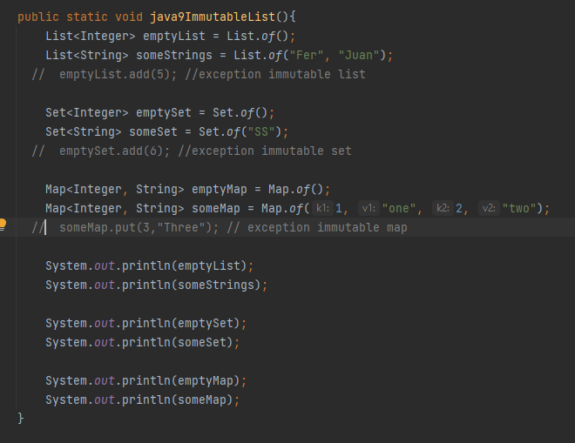

Private method interface

By default all methods are public in interface

Try with Resources Enhancement

From java 9 resources can be declared outside the try block

Connection conn= DriverManager.getConnection()

Statement stmt = conn.createStatement();

ResultSet rs = stmt.executeQuery(query);

Try(conn; stmt; rs) {

…

}

Stream new Methods

takeWhile-> stop If condition is false for any value

list.stream().takeWhile(i-> i<80).collect(Collectors.toList());

dropWhile-> it will start if condition is false for any value

list.stream().dropWhile(i-> i<80).collect(Collectors.toList());

OfNullable-> no null pointer exception, empty list

List l = null;

List emptyList = stream.ofNullable(l).collect(Collectors.toList());

Modularity

Before java 9 jars (must get complete jar even if 1 class is only needed)

After java 9 Modules (allow to get only modules needed)

Jar-> classes + interfaces

Module-> classes+interfaces+configuration data

Modules configuration data -> module-info.java

Module helloModule{

Requires java.base;

Requires java.sql;

Exports jff.xyz; -> java package to export

}



Private method in interface





Try with resources enhancement



Before java 9 all resources are inside try



From java 9 declared outside try and then refer to them

Stream enhancements





















If the value passed to this is null it will return an empty list not a null pointer













No need to create a java class, compile it and run it on command prompt, directly you can create the program there



Import classes to use in jshell









Now on java 9



We can take required module











Examples provided by java



example



Client using the created module:



Need to import module to use it

Add module in modules path



Import the module in the client project





JAVA 10











JAVA 11

Strings in java 11









lines





Strip







VAR INPUT ON STREAMS

JAVA 12





BEST





String new methods

indent





transform





JAVA 13

Text blocks for multiline String

String textBlock = “””

Hi

Hello

Yes “””;

Prints Hi

Hello

Yes

Java 14

When Null pointer is thrown more information will show up to easier identification

Java 15

Sealed Classes

Sealed classes and interfaces restrict which other classes or interfaces may extend or implement them.





Record Classes (similar Lombok)

A record class declares a sequence of fields, and then the appropriate accessors, constructors, equals, hashCode, and toString methods are created automatically.



Java 20

Virtual Threads

Virtual threads are lightweight threads that reduce the effort of writing, maintaining, and debugging high-throughput concurrent applications.

virtual thread is also an instance of java.lang.Thread. However, a virtual thread isn't tied to a specific OS thread. A virtual thread still runs code on an OS thread. However, when code running in a virtual thread calls a blocking I/O operation, the Java runtime suspends the virtual thread until it can be resumed.

Java 21

String templates (PREVIEW)

String productName = “widget”;

Double price = 29.99

StringTemplate productInfo=”Product ${productName}

Price $${price}”;

BIG O NOTATION













Sort O(N log N)



//Quicksort usually has a running time of n x log(n), but is there an algorithm that can sort even faster? In general,

// this is not possible. Most sorting algorithms are comparison sorts, i.e. they sort a list just by comparing t

// he elements to one another. A comparison sort algorithm cannot beat n x log(n) (worst-case) running time



**O(1) < O(logn) < O(n) < O(nlogn)**

BigO of Collectors.groupingBy -> O(n) it has to go all items, if not intermediate ops then O(n)

BigO of TreeMap O(logN)







Typically, when people refer to an asymptotic complexity ("big O"), they refer to the canonical forms. For example:

logarithmic: O(log n)

linear: O(n)

linearithmic: O(n log n)

quadratic: O(n2)

exponential: O(cn) for some fixed c > 1





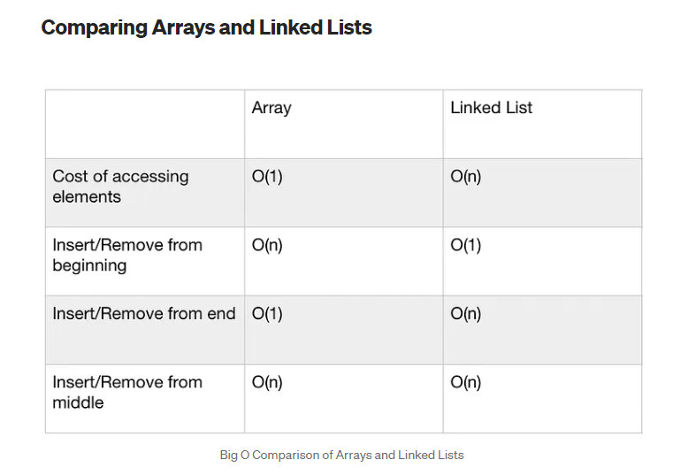

2 separate for of same input then O(2n) -> O(n)

2 separate for of different input then O(a+b)

2 nested for loop of same input then O(n2)

2 nested for loop of different input O(a*b)

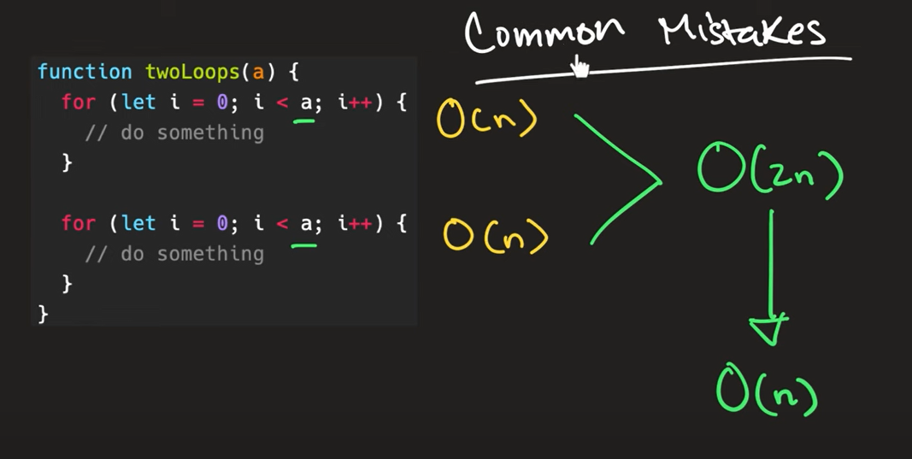

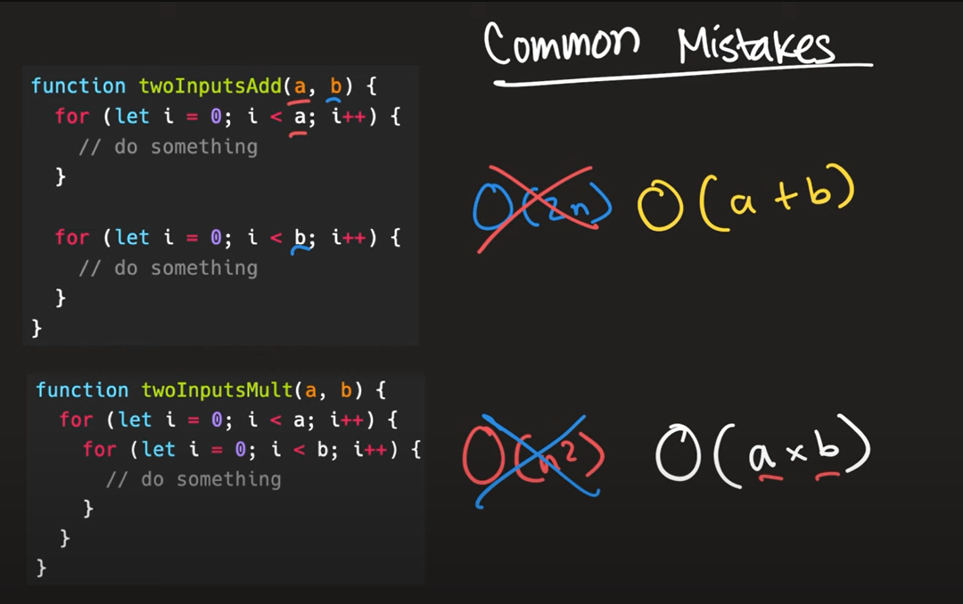

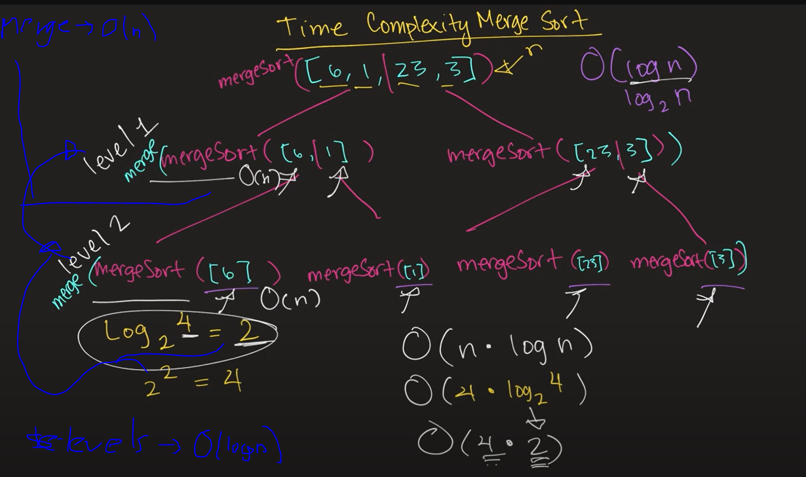

BIG O SPACE COMPLEXITY



It doesn’t matter how big the input is, what it does matter is if we create variables, data structures, function calls to deal with the input

O(1) No new Structures, method calls or variables

O(n) new data structure created and assign values from each one in input into this one





Normally we will consider only auxiliary memory to calculate complexity



Iterative only create constant values so O(1)

Recursive creates a memory stack for each one then O(n)

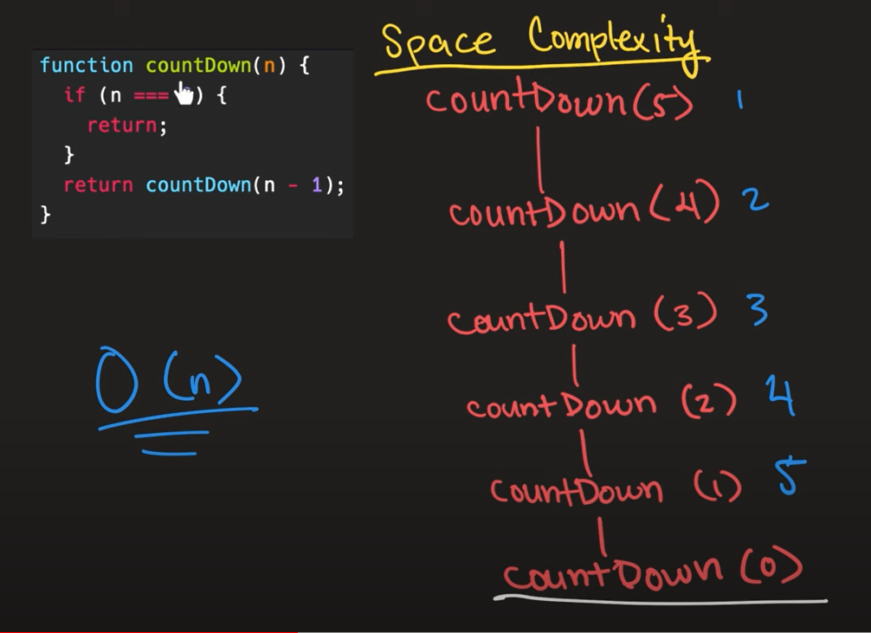

Int f(int n){

If(n<=1){ return 1;}

Return f(n-1) + f(n-1);

* O(2n) exponential, 2 a la n

O(N+P) where P<N/2 (N is the dominant, hence we can drop P)

* O(N)

O(N+P) (no way to determine relationship so we keep both)

* O(N+P)

sort each string and then sort the full array of strings

* Sort each string s
* Sort each string in array a
* Sort each string O(s log s)
* We have to do this for each string so:
* O(s*a log a)

For(int x=2; x*x <=n;x++)

* O(raiz de n)

DESIGN PATTERNS

We want to create an Object -> Creational Design Pattern

We have 2 objects, we want to use 1 object inside the other -> Structural Design Pattern

We have 2 objects, we want to include 1 object inside the other -> Structural Design Pattern

We have 2 objects, we don’t want to compose them, but we want to have some communication between those 2 objects -> Behavioral Design Pattern

Design Pattern

programming language independent strategies for solving the common object-oriented design problems

They are reusable in multiple projects.

They capture the software engineering experiences.

Creational Desing Patterns (way of creating objects)

Factory

Different plans with different rates, depending with input is the plan created and the resulting rate



Singleton



Prototype

When creation of objects takes a lot of resources or a lot of time.

Clone from another object which already exists

Builder

User class, UserBuilder static inside User. User Builder a constructor for each property and return the builder, user class constructor receives the userbuilder



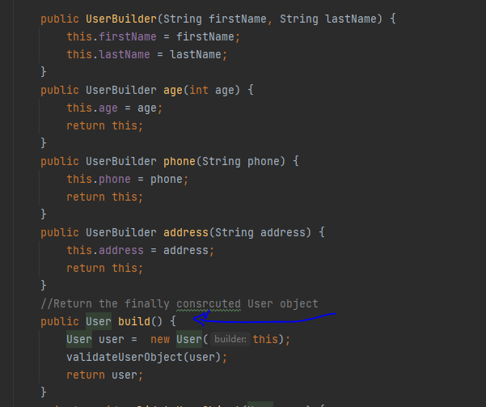

Structural Design Pattern

Adapter

An Adapter pattern acts as a connector between two incompatible interfaces that otherwise cannot be connected directly.

Credit card interface get bank info and get credit card. BankDetails class has more info.

BankCustomer adapter implements CreditCard and extends BankDetails.

When credit card method executes then it can have access to bankdetails information to complete info.





Bridge

Bridge is used when we need to decouple an abstraction from its implementation so that the two can vary independently

Color interface, Shape interface. Separately of concerns and associated with composition

It’s like a bridge that connects different parts of our code, making them work together smoothly.

Composite





Decorator

Lets you attach new behaviors to an object, by placing this object inside a special wrapper that contain these behaviors.

Façade

A simplified interface to put all the logic we require inside. To center it in case it was used by severlal parts of our app, also to restrict access.

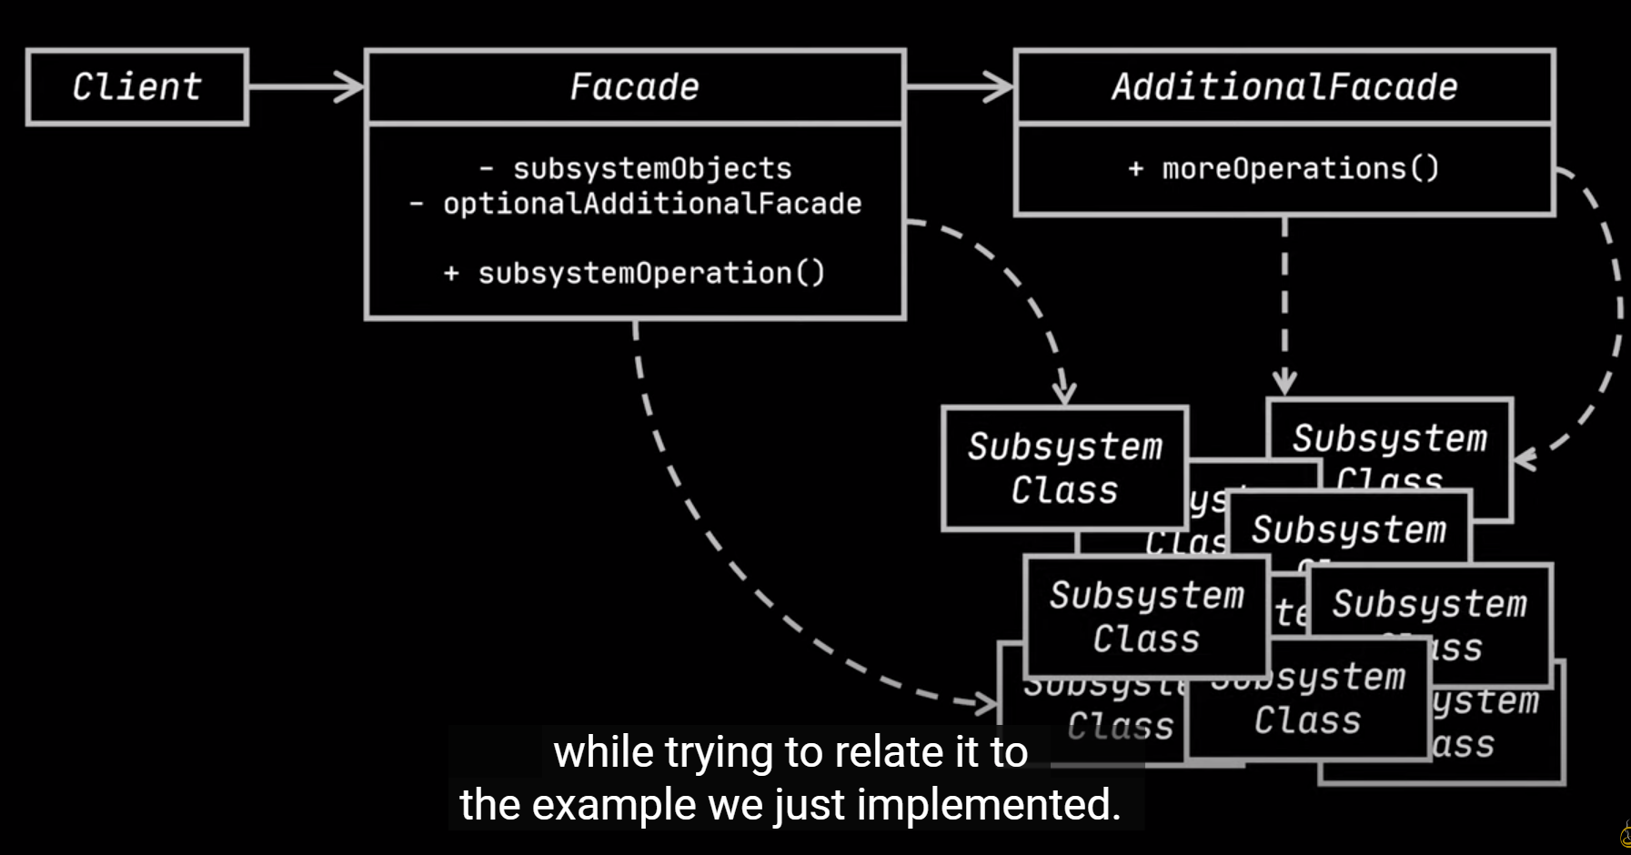

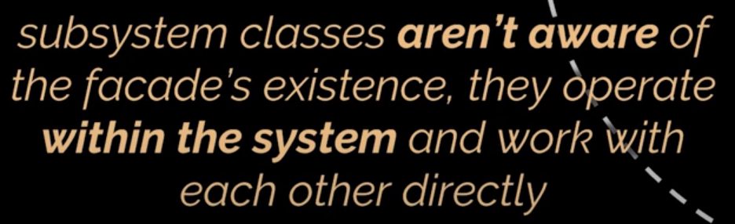

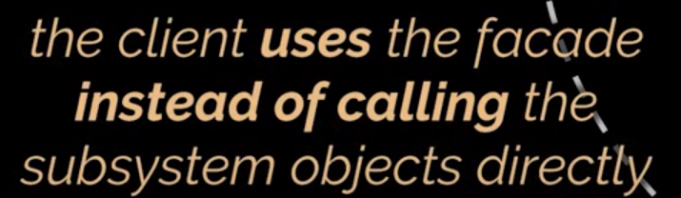

Flyweight

Proxy

Behavioral Design Pattern

Chain of Responsibility

Observer

Observer pattern is used when there is one-to-many relationship between objects such as if one object is modified, its depenedent objects are to be notified automatically.

Observable setChanged and notifyObservers. Observer update

Iterator

Strategy

Factory Design Pattern

Define interface or abstract class to create an object, but let subclass decide which class to instantiate.

Promotes loose coupling eliminating the need to bind application specific classes in the code

Use when a class doesn’t know what subclass it will require to create.

Abstract class

An abstract class is a class that is declared abstract—it may or may not include abstract methods. Abstract classes cannot be instantiated, but they can be subclassed

Singleton Design Pattern

only single instance should be created and single object can be used by all other classes.

Saves memory because object is not created at each request. Only single instance is reused again and again.

Singleton pattern is mostly used in multi-threaded and database applications. It is used in logging, caching, thread pools, configuration settings etc.

Prototype design pattern

cloning of an existing object instead of creating new one and can also be customized as per the requirement. if the cost of creating a new object is expensive and resource intensive.

Builder design Pattern

construct a complex object from simple objects using step-by-step approach.

It is mostly used when object can't be created in single step like in the de-serialization of a complex object.

It provides better control over construction process

Structural Design Pattern

are concerned with how classes and objects can be composed, to form larger structures

simplifies the structure by identifying the relationships

ex: Adapter, Bridge, Decorator, Façade, Proxy

Adapter Pattern

It allows two or more previously incompatible objects to interact.

It allows reusability of existing functionality.

When you want to create a reusable class that cooperates with classes which don't have compatible interfaces.

Bridge Pattern

create a bridge interface that uses OOP principles to separate out responsibilities into different abstract classes.

Decorator Pattern

attach a flexible additional responsibilities to an object dynamically.

uses composition instead of inheritance to extend the functionality of an object at runtime.

greater flexibility than static inheritance, changes are made by coding new classes.

Façade Pattern

just provide a unified and simplified interface to a set of interfaces in a subsystem, therefore it hides the complexities of the subsystem from the client.

a facade encapsulates a complex subsystem behind a simple interface.



Façade ->



Proxy Pattern

provides the control for accessing the original object

It provides the protection to the original object from the outside world

Behavioral Design Patterns

the interaction between the objects should be in such a way that they can easily talk to each other and still should be loosely coupled.

Chain of Responsibility

sender sends a request to a chain of objects. The request can be handled by any object in the chain

It adds flexibility while assigning the responsibilities to objects.

Iterator Pattern

When you want to access a collection of objects without exposing its internal representation.

Observer Pattern

when one object changes state, all its dependents are notified and updated automatically

Strategy Pattern

defines a family of functionality, encapsulate each one, and make them interchangeable

J2EE

Servlets

Class that allows to extend the capabilities of an application server, accept requests and return responses



Request.setAttribute(“name”, value);

Request.getParameter(“parameterName”);

String [] sizes = request.getParamaterValues(“array”);

Request.getHeader(“headerName”);

Cookie cookies[] = Request.getCookies();

HttpSession session = request.getSession();

Request.getMethod(); //get or post

Response.sendRedirect(“newUrl”); //url changes

RequestDispatcher dispatcher = request.getRequestDispatcher(“result.jsp”);

Dispatcher.forward(request, response); //url doesn’t change

Servlet init param (only available for specific servlet)



Context param (available for all servlets)



Scriptlet <% %> allows to add java into jsp

Directive <%@ %> instructions to container as imports

Expression <%= %> prints value inside it

Declaration <%! %> adds code outside service() can declare vars or static methods

Servlet lifecycle





Jsp

HTML tags and JSP tags. The JSP pages are easier to maintain than Servlet because we can separate designing and development

A JSP page services requests as a servlet.

Jsp lifecycle



Jsp servlets scopes

Application, session, request, page

<jsp:useBean id=”a” class=”clase” scope=”page”> //declara e inicializa el bean

<jsp:getProperty name=”beanName” property=”propertyFromBean”>

<jsp:setProperty name=”beanName” property=”propertyName” value=”propertyValue”>

<jsp:include> //imports

<jsp:param>

<jsp:forward>

Expression Language

Permite acceder a properties o invocar métodos

${beanOrMap.properyOrMapKey}

${prefix:FunctionName()}

JSTL

The JSP Standard Tag Library (JSTL) represents a set of tags to simplify the JSP development

<c:if test=”booleanTest”>

<c:out value=”${contentToShow}”

<c:forEach var=”movie” items=”${movies}”>

${movie}

</c:forEach>

Filters

A filter is an object that performs filtering tasks on either the request to a resource (a servlet or static content), or on the response from a resource, or both.

Can Change either header or content or both to request or response



doFilter()

method executed

JMS





Why to use messaging

Applications with different languages and architecture communicating simultaneously



The four applications can communicate each other through the message-oriented middleware

Ex patient registration running on linux developed in java

Pation Clinicals running on windows developed in .net, etc

MOM exposes an api for each of this platforms to exchange messages

Messaging is more reliable, the MOM will persist the message, messages are not lost



It can create clones so in case the queue starts increasing it adds a clone instance, which works asynchronously, and improve the response efficiency

Scalable

It is scalable, by creating multiple consumers or asynchronous listeners as the load in our app increases



Flexibility, if we want to replace any of the apps like patient clinicals, we can do it without affecting the rest of the apps, as long as the contract remain the same



JMS

Specification (Set of rule), MOMS comply with the standard.

API Developers don’t need to learn the api for each vendor, just learn the JMS standard, by doing that you can communicate with any message servers following the standard.



JSM supports two types of messaging models, POINT TO POINT and PUBLISH/SUBSCRIBE



Point-to-Point (P2P)

Allows sending and receiving messages synchronously and asynchronously through virtual channels called queues. JMS provider allow to create this queues and our applications will then put the message on this virtual channels and another application will consume that message

It is consumed only once and by only one application, once it is consumed it is gone from the queue

The JMS provider is the responsible to ensure that the message is consumed only once

P2P messaging supports Async Fire and forget (the app1 send the message to the queue and then forgets about it) and app2 will simply read it

P2P also supports Synchronous request/reply messaging app 1 sends a message to the queue, app 2 consumes it, processes it send the message back to a different queue which is consumed by app 1 as a response



Publish/Subscribe

The message are publish to a virtual channel called topic, the message producers are called producer and the consumers are called subscribers, multiple consumers can receive same message without them having to request or pull the topic

Producer sends a message to the topic, the topic gets sure a copy of the message is sent to each subscriber

Ex news paper sub, a same copy are sent to all the subscribers



JMS Provider

Messaging server which implements the JMS specification

Run artemis







JMS 1 Components

Connection factory provided by the provider like activeMQ

Destination (queue or topic) provided by the provider like activeMQ

Connection factory and destination accessed by JNDI

Connection like a physical connection with the provider

Session created from the connection, unit of work in jms, we can create any number of sessions from the connection with the session you can create a message and a message producer (queue producer, topic producer)

Message

Message Producer

Message Consumer

Create Project



Only dependency needed, maven project

Add jndi properties file







Queue Browser



JMS 2.0

Removes boilerplate code to get a connection with JMSContext



MESSAGE

All data or events are communicated through message, and the rest of the components just help to transfer the message



Messsage Header

Metadata

Provider set headers (automatically assigned to a message by the provider ex active mq)

Developer headers



Message Properties



Test priority



Reply messaging



Dynamically create a reply queue



Associate a particular reply to a particular request (for multiple app requests)

Messageid and correlationid help to link a particular request to a particular reply



Set message expiration



When a message expires it is not lost completely, it will be stored in a particular place (configured automatically)





Second name is the one configured in the provider

Delay delivery



Add custom message properties



Message Types



BytesMessage ex:



StreamMessage ex



Map message ex



Object Message ex:





JMS 2

Sent types easies using the overloaded method of send







Help and contact, contact us, selling, payment hold on your sold items, chat with our automated assistant

When to use P2P

One to one communication

Once the message is read is gone



Asynchronous process

The client don’t need to ask for the message, once it is one it will be advised by the listener







Complete





Publish/Subscribe Messaging, when to use

When we wanto to send the message across applications







PUBLISHER



SUBSCRIBERS





Get same message.

Durable subscription

What happen if one of the subscribers is down when the message is sent, they will lose the message (producer delivers the message on the topic and then deletes the message), for this case we have durable subscription.

We pass a unique clientId and a subscription name to each subscriber, then the jms provider will keep track of the subscribers who have received the message using this clientid and subscription name, if there Is any that hasn’t receive the message, it will retain the message until they get the message, once the subscriber is up it will deliver the message to it and the remove it from the topic.



Shared consumer (many consumers on same subscriber)



Message Filtering

Consumer want to consume the message only in a particular condition

Only work on message properties and header, not on the payload

It is added on the queue so only desired messages will reach the consumer If apply

Sender app is responsible of setting the properties and headers





Only on this headers











JMs guarantee messaging through message acknowledgments





It happens automatically, once it is send by the producer and received by the jms server it returns an acknowledgement and is responsible of sending that message to the consumer, the ack sent doesn’t mean it has been deliver to the consumer.



Dups OK Acknowledge explicitly has to acknowledge

It can send the message more than one to the same consumer, it can send the message any number of times until it respons it has been delivered



Client Acknowledge

Jms consumer takes the acknowledgement in its own hands (jms server not blocked) jsm consumer will acknowledge it in some point while the jms server can work on other thing



On message consumer:

You need to acknowledge it explicitly on the client, otherwise the message provider will retain the message on the queue



Transacted messages

It wont go to the jms server until a commit() has been send, if before that a rollback is send then it wont reach the jms server (they will go to a cache where it stays until a commit or a rollback is received)

On the consumer side you can receive messages but until you give a commit() they will be gone from the queue or topic, jms server will retain the messages till that, rollback here will produce the jms server to resend the messages for processing to the consumer again



Only message 1 will be delivered



Only message 1 delivered



Consumer context as transacted and send commit to make it remove from the jms server

Security





Artemis-users Users and passwords allowed to connect

Artemis-roles roles allowed

Broker.xml

Users and roles will be set in this file in the <security-settings>

Artemis-users



Artemis-roles



Broker.xml

 jndi properties







Message grouping

Send a group of messages to a single consumer



The Java Message Service (JMS) was designed to make it easy to develop business applications that asynchronously send and receive business data and events. JMS supports both messaging models: point-to-point (queuing) and publish-subscribe.

JMS clients interact by sending and receiving messages using the JMS API. A message is composed of three parts: header, properties, and a body.

JUNIT









Junit vintage

Junit3 and junit 4 compatibility

Junit Jupiter

Junit 5









































































































































Spring Rest example



@RestController makes a class an endpoint for spring

@RequestMapping is like @Path allows to define a uri for the resource



Database config with spring



@RequestBody allows us to get objects and parse them to json (no annotations on the model class needed)





Persisting model into db



Inherits all methods to create read delete and update for a UserEntity, which has an id of type long

@Repository for spring to generate this bean at start up





Random example

Security



Just adding the spring boot security dependency makes the ws secured, it generates an automatic token for use







First configure is authorizing any post request to /users to pass without authentication, the rest other anyRequest needs to be authenticated

Second method configures an encoder for the passwords used in the web security

Our interface extends UserDetailsService, then this web security will apply for our code





Method used by spring at

Authentication Filter used when an http request is sent for an user to sign in to the application



Add filter to the security of the application



Filter

Will use the loadUserByUsername when trying to authenticate with this filter, that method we added on the service since it extends the interface UserDetailsService





Authentication we get by default



Changes default login path to out own customized path for login





Entra al filtro en attempt authentication despues pasa por loadUserByUsername para obtener el valor de la base de datos, entonces pasa a successful authentication

Reuse token







Get property from file



Path param

Adding path att to the get mapping and storing the value with @PathVariable



Consumes and Produces in spring



We can configure an Exception handler which will trigger when one of the configured exceptions is thrown and not handled, it allows you to do something different according to the type of exception







Custom error object returned



General Exception handler for all other kind of exceptions that might be thrown



Paging and sorting repository give some more functionality for paging and sorting, but keeping the use CrudRepository offered





Get paginated list

Run project outside sts

Open a command line and go into your folder at the root where pom.xml is located

Mvn install, build project and run tests

Mvn spring-boot:run



OneToMany ManyToOne

User Entity (who owns the addresses)



Address Entity



mappedBy should match the nam of the userDetails in the Many to one relationship



Map properties from collections

Add hateoas



**Generate link and add it to the response**





With methodOn avoid harcoding

Junit checks the code methods normally not communicating with external entities

Rest Assured tests the whole rest endpoint, sending the request validating the response





@InsertMocks class which will be used to test and which will require some mocks to be injected on it

@Mock mock object which will be created for mockito, using when allows to mock a response on the wanted method

Rest Assured

Http requests are real, request and reposnse objects are real

Exclude library maven



Rest assured example (end point must be up and running since it is a real http request)



Working with the response body



Working with the headers from the response





Allows to execute the tests in order, by the name of the method in the NAME_ASCENDING case.

Use from the result var from 1 test in a next test, assigning the result value to a static var



Path param



CORS

Allow cros requests like ajax on your rest service

Allow asynchronows requests

It is by default unavailable

you configure for the rest service to allow those

same origin only if port, protocol and host is the same, you configure origins to be able to do cross origen request



Default error when asynchronous request to a rest service is sent

All origins authorized



Allow specific origin



Multiple origins allowed



All methods allowed specifying @CrossOrigin at level class}



Configure to allow all rest controllers in the project



Spring Security Configuration for cors (if we use spring security in the project)





Swagger

1 Configure



2 If Spring security enabled, configure it to allow swagger



Add headers for the swagger methods with ApiImplicitParams







Mvn clean removes target folder

WEB SERVICES

Website -> human consumption

Webservice -> app consumption

WSDL

Web service contract, what you share with consumers, info with methods, args and return type

UDDI

Where you can register a web service, you can get wsdl from it

SERVICE FIRST

First service code then wsdl

CONTRACT FIRST

Wsdl first code next

SYNCHRONOUS SERVICES

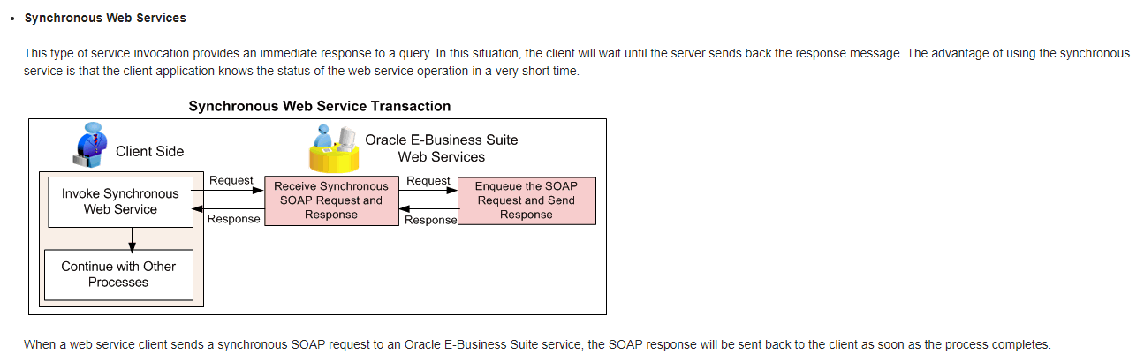

Wait for the response to continue.

ASYNCHRONOUS SERVICES

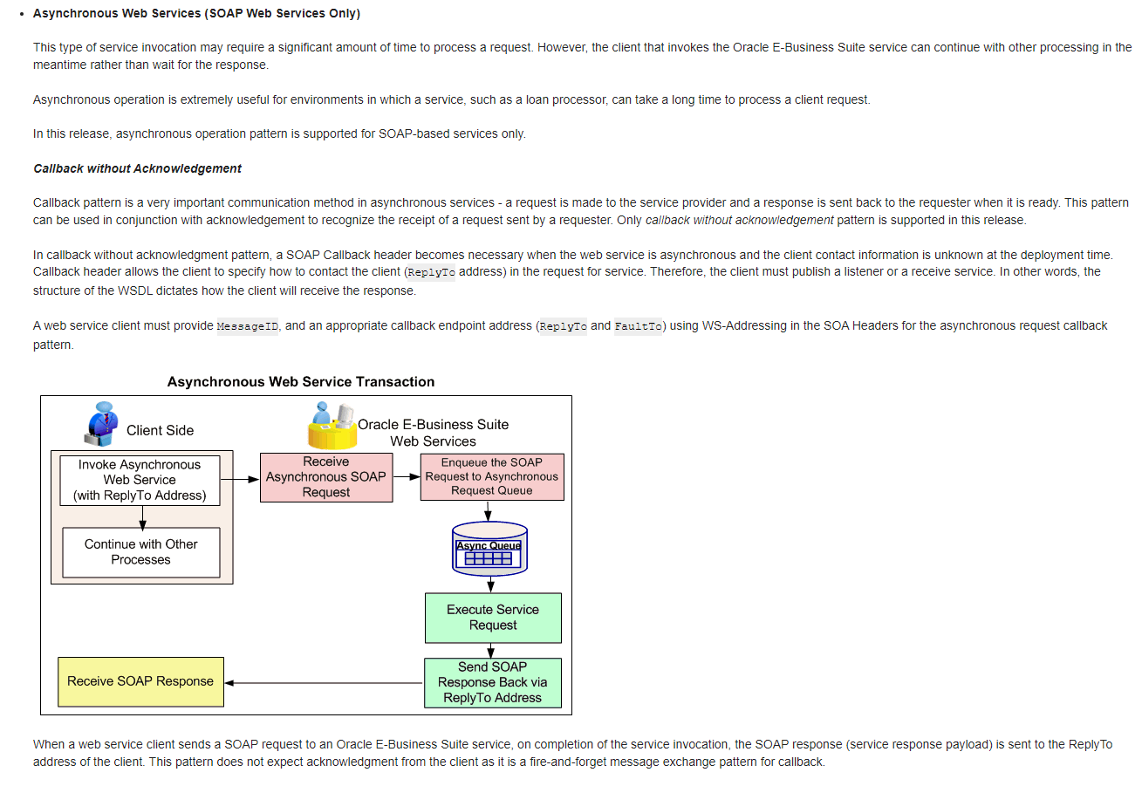

Request and forget approach, don’t need to wait for the response and continue executing other tasks

Service Discovery Pattern

A service discovery pattern enables locating microservices within the network. It uses a service registry (a centralized server) to keep a global record of all microservices’ network locations.

All microservices must register and disclose their locations to the central service registry at set intervals. Clients (service consumers) can retrieve the locations of each microservice by connecting to the service registry, after which they can directly call the various services to complete a task.

Primary Service discovery patterns:

Client Side discovery patterns

Here is how a client-side discovery pattern works:

A service consumer tries to locate a specific service provider by searching the service registry.

1. The service consumer selects a suitable, available service instance with the help of a load balancer.
2. The service consumer makes a request.
3. Once the service initiates, its instance’s location is recorded in the service registry. When the instance is terminated, this information should be deleted from the registry.

Server-side discovery pattern

Here is how a server-side discovery pattern works:

* The client-side service consumer does not know about the service registry. Instead, it makes requests through a router.
* The router looks for an available, suitable service instance in the service registry and reroutes the request.

In this pattern, clients do not do service discovery or load balancing. Instead, the API gateway works to select a suitable endpoint for a given client-side request.

A server-side discovery pattern is language-agnostic and framework-agnostic. However, it requires the deployment environment to provide a load balancer and to remain highly available.

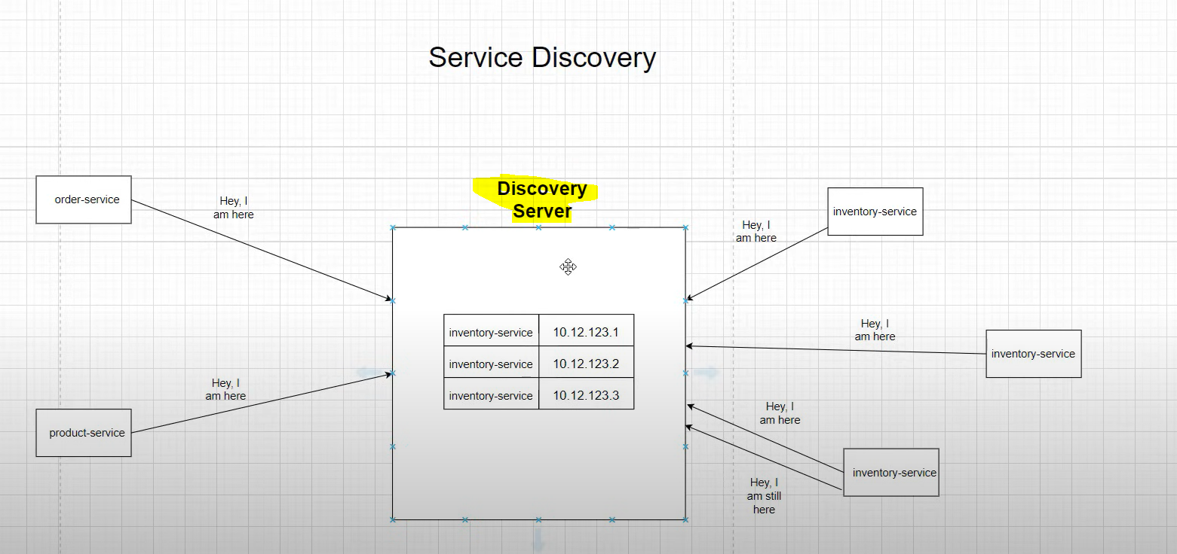

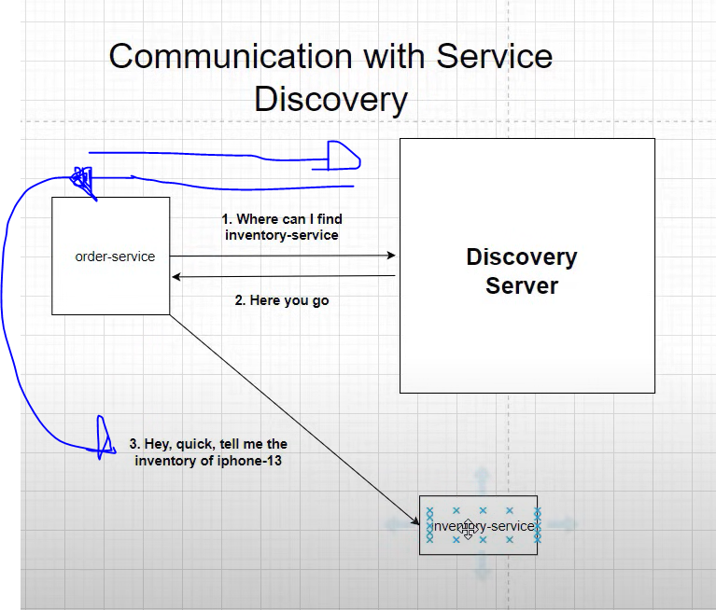

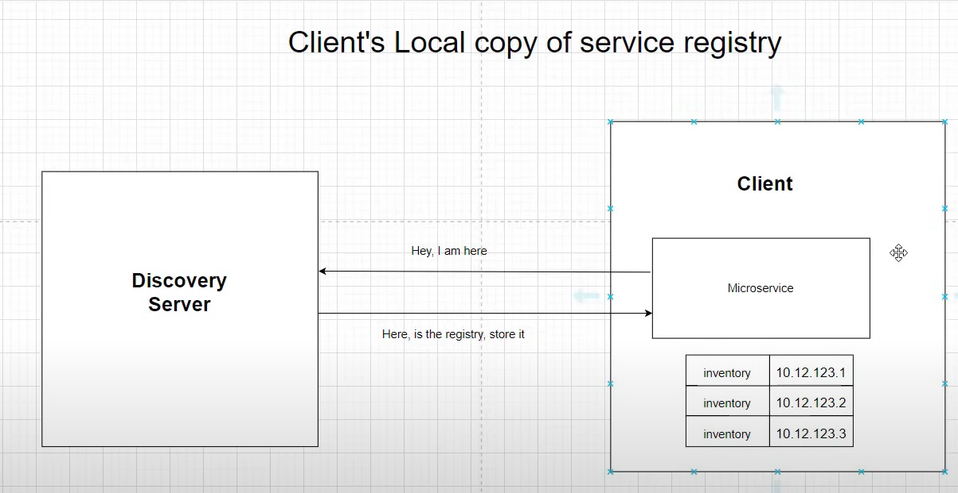

API GATEWAY

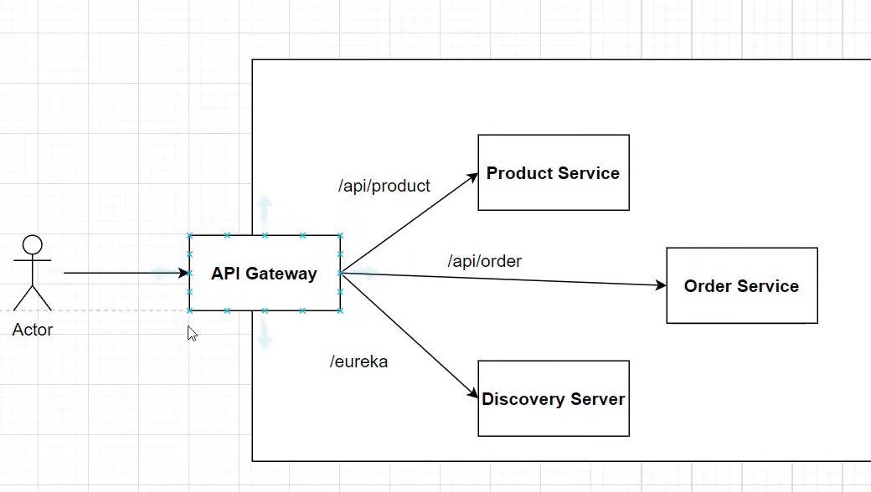

Microservices can have multiple instances and ports, so harcoding the url wont work, for this we will have a call to the API Gateway who will have the information to call our microservices.

Api Gateway can also take care of cross cutting concerns: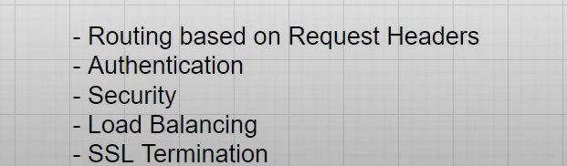

Secure Microservices

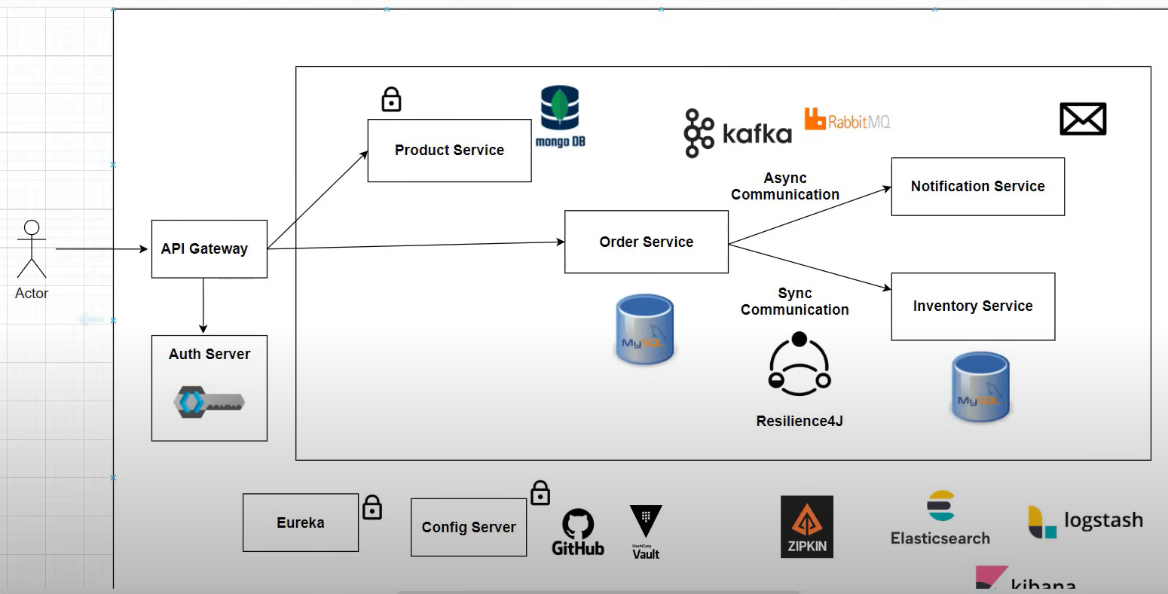

OAuth2 using KeyCloak

OAuth 2

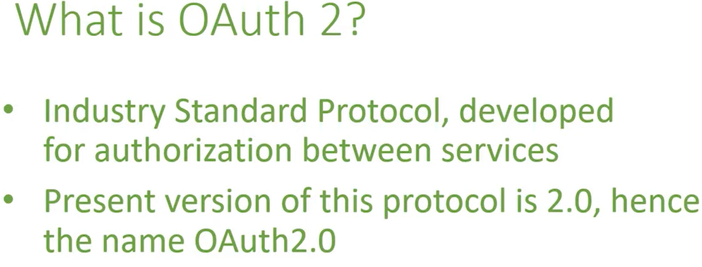

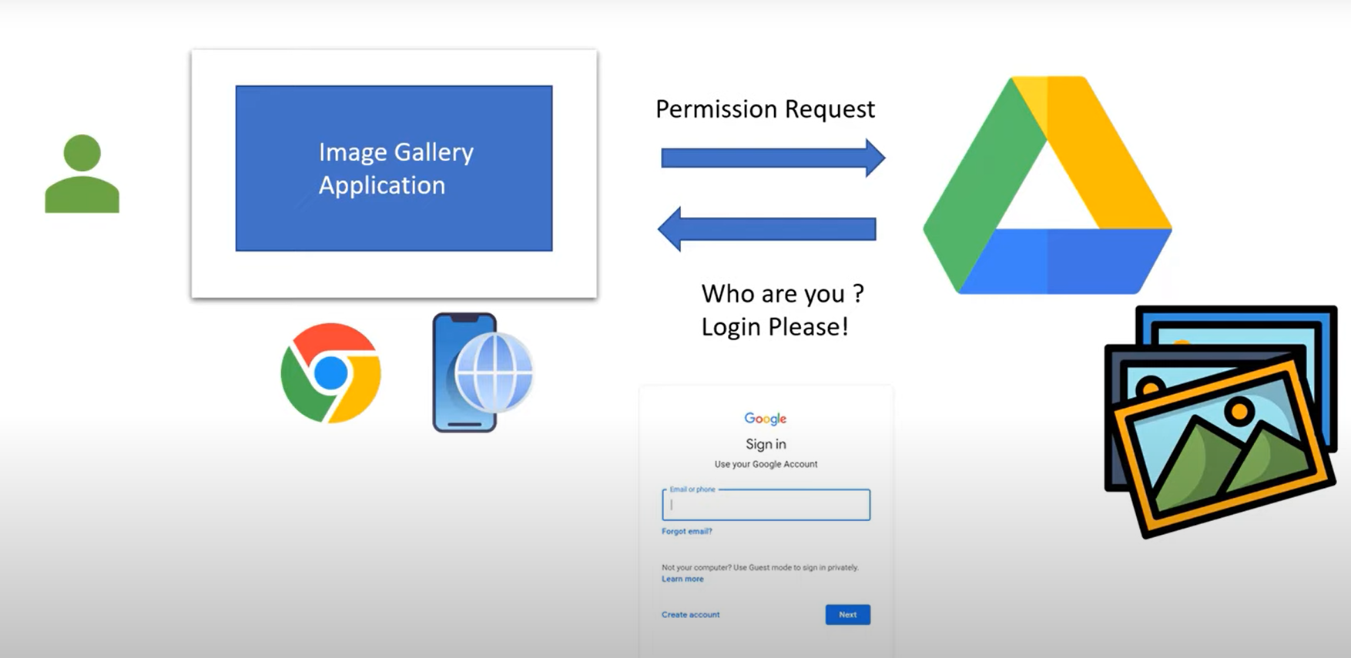

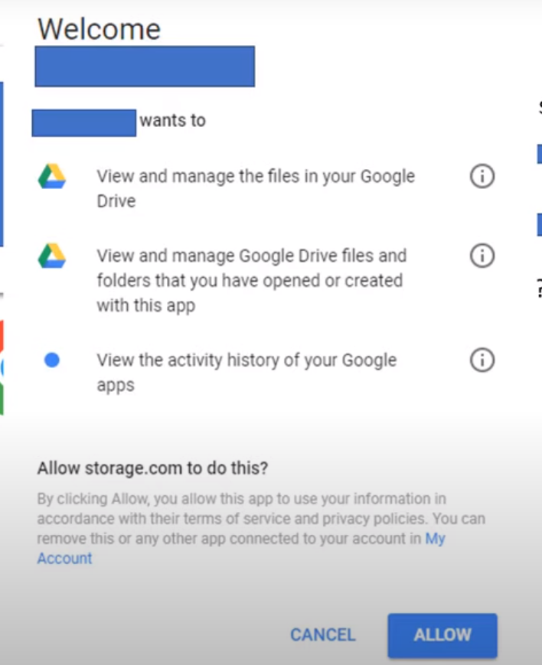

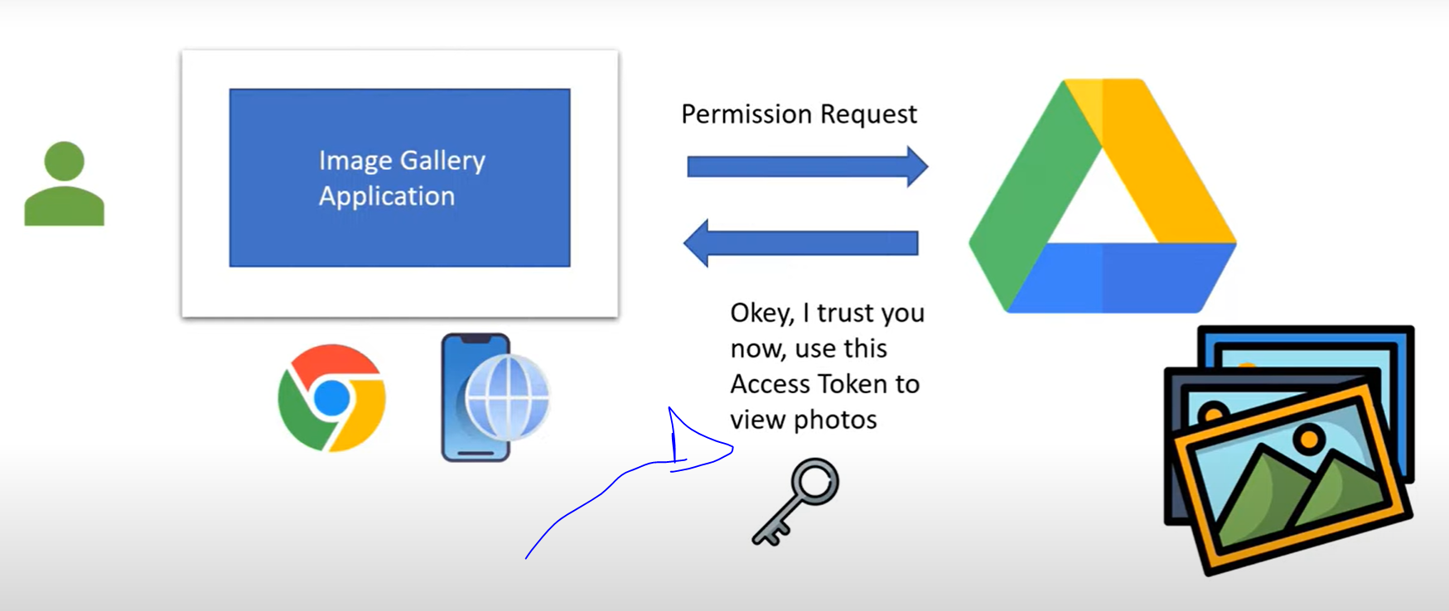

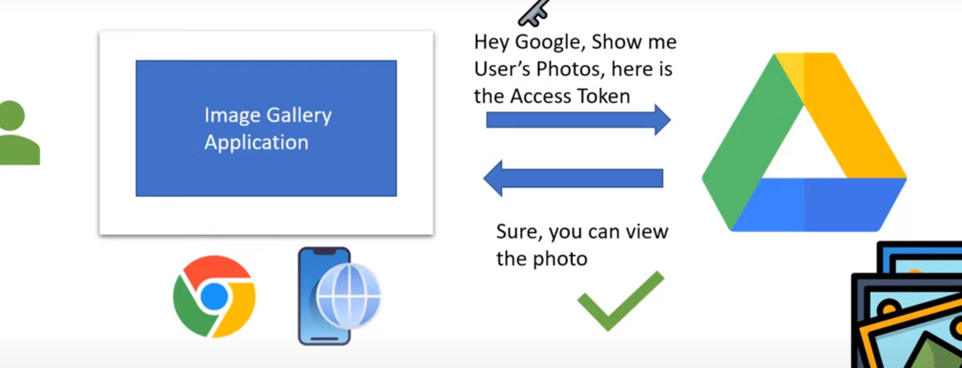

Resource Owner

Owner of the resource we want to access

Resource

Resource to see

Resource Server

Storer (Google drive for example)

Client



Authorization Server

Server that generates and validates access tokens for clients and permissions of users.

(AWS Cognito, Azure AD, OKTA, Key Cloak)

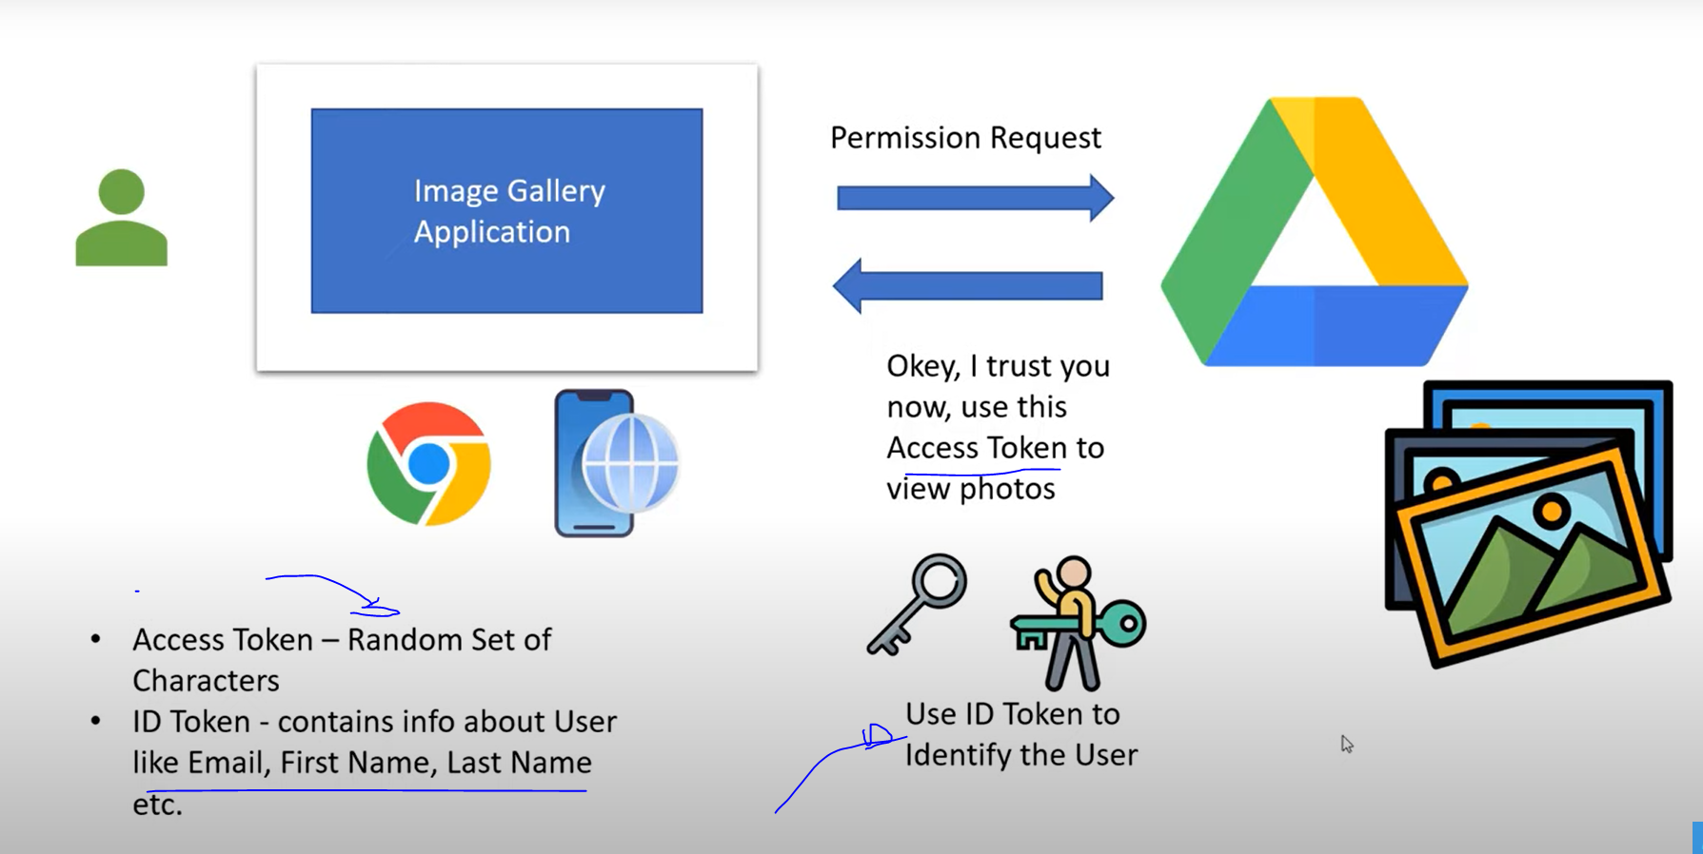

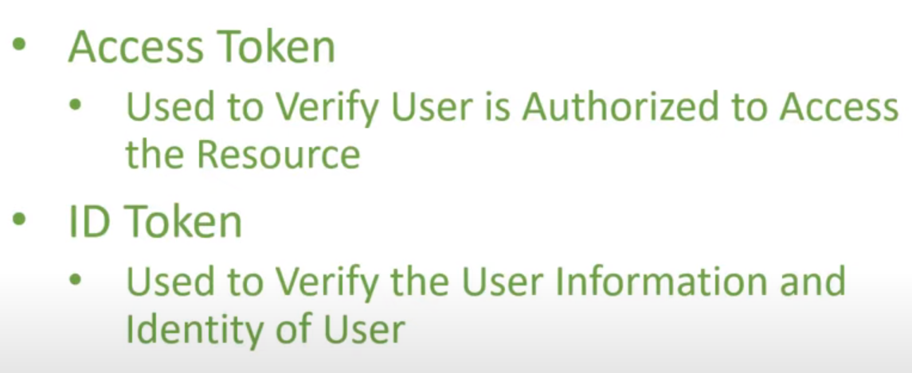

Distributed Tracing

Helps to track the request from start to finish.

Why and where it failed.

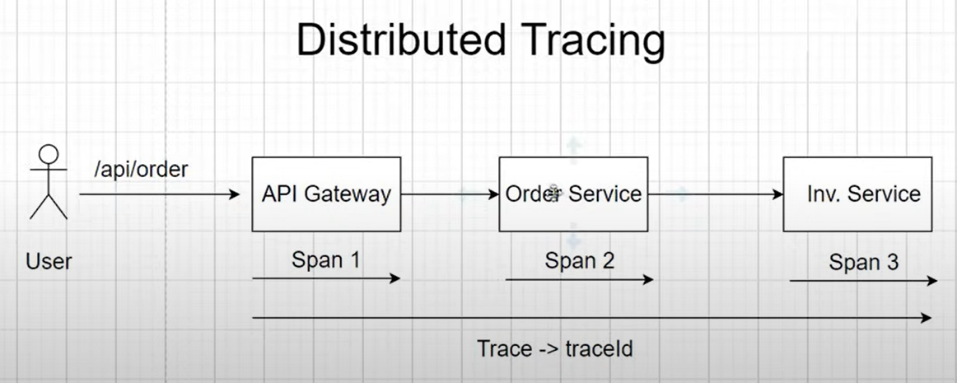

TraceId unique identier

Span id trips in the flow

Implement: use of Spring Cloud Sleuth, distributed tracing framework



Log with spanid and traceid after enabling the library

Using zipkin to find traceid (using locker container)

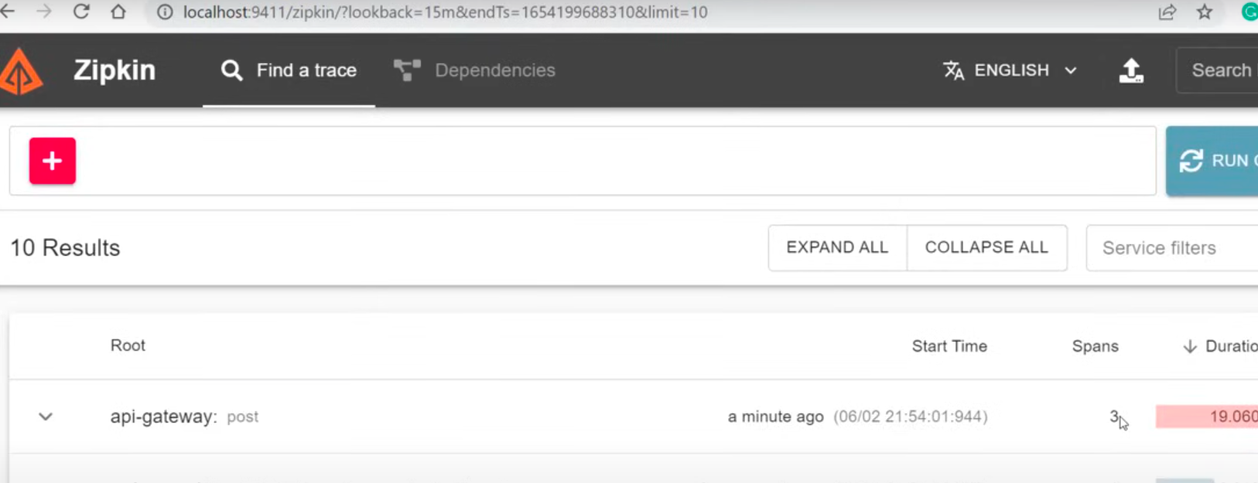

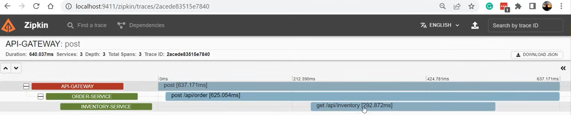

Event Driven Arquitecture

Async communication, send the request and forget about the response

Apache Kafka container

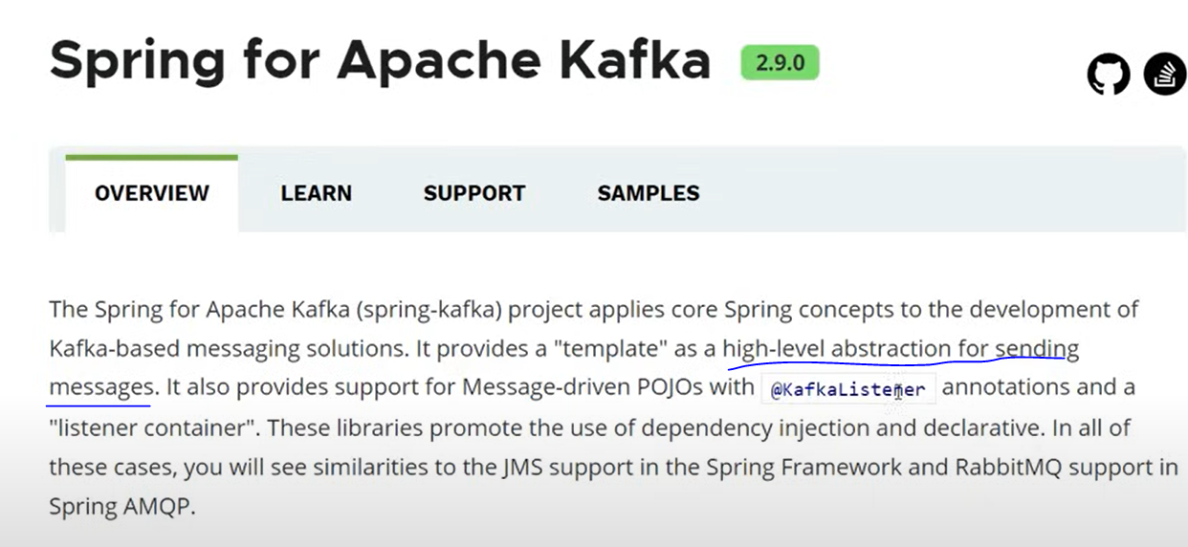



JAX B

Associate Java object with xml, needs no args constructor

Soap only supports Xml and Post method





contract



Xml carries both data and metadata, allows to create custom markup



XSD

Xml schema definition, defines the blueprint of an xml document.

What elements, attributes, namespaces, order, number of ocurrences of each element and the restrictions.

 



Order xsd says what elements, attributes and in which order, elements can show in the .xml

Xsd is used because when app1 and app2 are exchanging xml each other, then one could follow a different approach which will affect the result, with the xsd we have a contract that controls what elements can be accepted.

Namespaces





From here we can use amz instead of the whole target namespace in order to refer to its value



Schema xml example:

xsd



Xml



If xml doesn’t follow the xsd template it will give an error when validating



Max occurs, min occurs control how many times the element can show up in the xml



elementFormDefault

If the schema is marked as qualified then each elements in the xml should have the prefix (txn this case because of the xmlns:tns)



Unqualified allows to have the xml without the prefix



attribute





Id Added as attribute on the root element





Soap:body has de payload





Soap header helps to send metadata

WSDL





Types

Here you add the types you need to exchange information ex: string

Messages

Parameters and return types

Operations

Methods the service has

Port type

holds the operations the service has

Binding

How the service can be consumed

Service

Tells how to access the service, which url

You can have multiple services in the same wsdl using the port element

Binding style determines payload, messages and if the schema can be validated or not









Approaches to develop soap ws







When wsdl is generated

Webmethod become operations

Web param, web result and Webfault become messages



Responsewrapper allows to customize the response returned



Create project

Copy the wsdl into the project to with it generate the stubs

With the tool or maven plugin generate automatically the stubs from the wsdl



Create the client



From the wsdl obtain the service and then the port type which will have the methods or operations available on the wsdl to invoke

Down to top ws creation (first java then wsdl)



Mark request and response (beans) with annotations



@XmlElement is optional only if you want to control the name of the field, if not the name of the var will be used by default only using @XmlType on the class

Mark endpoints with annotations



Add configuration



After running the cfx plugin will find the classes annotated with @WebService and will generate a wsdl based on it

Configure security on web service





On the ws config class add after the published endpoint the interceptor with the class which will provide the required authentication info.



Configure the callback to retrieve and set the password on the callback



Send the username and password on the header to be retrieved on the callback

Jax ws handlers

Similar to interceptors, allow to modify header or body (for cross cutting concerns)











@Suspended says Jax Rs this method is asynchronous

Method should be void and response.resume will be in charge of returning the response when ready



Client for the asynchronous call





Basic auth

Federated Authentication

One application using another application to login:

ex: you try to post a comment on a website which redirects you to google to authenticate then google confirm authentication to the website which allows to post the message with that user from google

Delegated Authorization

You use a website which will return docs which allows to save to google drive, instead of sharing the data from google drive to the site, the site redirects you to google drive to authenticate and then the site will have access to save to the google drive.



OAuth is the standard that allows this type of communication







Client for attachment with Apache CFX



Rest Service





Spring mvc



Spring Rest







XmlRootElement not necessary, done automatically by Spring with Jackson libraries added on pom

Post is not cacheable





REST SERVICES

Configuration without servlet config only extending application to configure a rest endpoint with jax rs



@ApplicationPath has the prefix of the url for our resources

Every request generates a new instance of the resource (request scope)

When the request is served then it is destroyed

@Singleton

Permite convertir un recurso en singleton asi q solo sera creado una instancia para todos los request

Instance variables path and query params:



Don’t work for Singleton

Param converter

Allows to convert any sent param (path, query, etc) to a own created model type





Method is converting from string to a custom data type MyDate



Provider must be registered which will be able to map the param to the requested custom data type

MessageBodyWriter MessageBodyWriter

Converts the raw content sent in the request to our custom data type

Param converter for params message body reader writer for raw content

Message body writer



Date to text plain should be converted, it needs a message body writer which can convert this









Invocation

You create an object with all the request information which is not sent yet, it can be passed to someone else for them to make the actual call whenever they want even being able to modify the request before



Getting a generic type as response

Needs an implementation of generic type with the generic type which will be the response





Filters help for cross cutting concerns

Container Response Filter will be called when the response is about to be sent back



Filters is guaranteed to be executed no matter if the response is an exception

Filters manipulate headers or metadata

Interceptors manipulate entities (input and output streams





Web service feature

needs resource based uris

http methods

response http status codes

message headers

Hateous

To provide usesul links to resources in the api response

Richar Maturity Level

0 no rest

1 individual resource uri

2 http methods and status codes

3 Hateous

Jax Rs

Common api to work with Rest Web Services (Interfaces and Annotations)

Jersey, Rest Easy implementations of Jax Rs

Resource

A resource is an object with a type, associated data, relationships to other resources, and a set of methods that operate on it.

Config of jersey

There is a servlet configure, listening to a path and then choose the correct resource to handle the request.



@Path

Allows to specify the uri for a resource to execute

@Get

Associates a method to the http get method.

@Produces

Return content type which will be return by the resource

Resource Example



@PathParam

Allows to take a path param and use it in the resource





RequestBody receives the data and mapped into a java object



Message Body Writer Interface

Necessary libs to convert from java to other format(xml, json). Ex convert from java message to json

Message Body Reader interface

Necessary libs to convert from any given format to java

@Consumes

is used to specify which MIME media types of representations a resource can accept



@QueryParam

Allows to take parameters sent and use them in the resource





@HeaderParam

We can fetch header parameters



@CookieParam

We can retrieve the entire cookie by injecting the Cookie with the @CookieParam JAX-RS annotation



Create cookie on the response



@Context

inject a variety of resources in your RESTful services. Some of the most commonly injected components are HTTP headers, HTTP URI related information.







@BeanParam

Allows to create a bean, replace a whole lot of the other param annotations

 

(will receive form params first and list and header param content type, with that creates a CustomerInput object with the @BeanParam

Subresource

RootResource delegate the responsibility to a sub resource.

Subresource gets all parameters from the root resource

Root Resource

@Path(“{messageId}/comments”)

Public CommentResource getCommentResource(){

Return new CommentResource();}

Sub resource

@Path(“/”) //its already defined in the root

Public class CommentResource(){

@Get

Public String test(){

Return “test”;}

@XmlTransient

Allows to ignore a property from that resource

Return Response

Instead of returning an object, we can return a response object which can include headers, status code, entities, etc.



Return Response.created(uri)

.entity(newMessage).build();

@Provider

Registers the class to Jax rs for them to know its there and can be used

An application can extend JAX-RS runtime by implementing one or more interfaces as specified by the JSR-339. These implementations may be annotated with @Provider for automatic discovery during scanning phase

Web application Exception

Jax-rs set of exceptions, maps based on status in the response

Accept header

Can be added in the request, this is the content type it needs. If the class doesn’t support it then it will throw an exception

Param converters

Jersey includes them, to convert String to primitive

Param Converter Provider

Says to jax rs to use that paramconveter for a custom data type

Param Converter

When you need to convert a String to a custom datatype, it is need to create the class which implement param converter and register it on the param converter provider

@Provider

Public class MyDateConverterProvider implements ParamConverterProvider{

@Override

Public <T> ParamConverter<T> getConverter(….

….

MessageBodyReader, MessageBodyWriter

Convert the raw content from the request to a java type

Param Converter

Convert params to custom data types

Filters

For cross cutting concerns on the resources, for header information and metadata only

ContainerRequestFilter, before the request goes to the resource

ContainerResponseFilter, after the request finish on the resource

Needs to implement what you need or both

@Provider

Public class PoweredByFilter implements ContainterResponseFilter{

@Override

Public void filter(….

….}

Filter executes no matter if it was a success or error request.

restApi Stateless

do not maintain information from previous request

Basic Auth

Digest Access Authentication

Asymmetric

OAuth

Interceptors

Similar to filters but to manipulate input and output streams (filter only headers and metadata)

ReaderInterceptor modify request

WriterInterceptor modify response

HTTP Methods

Get-> get from server

Post -> post to server

Put-> submit data to server, idempotent

Delete->remove a resource

Header Content Type

To know how to parse the data (xml, json, etc)

Header Accept

To know how we want the format of the response

Richard Madurity Model

Level 0 plain old xml

Level 1, individual uris for resource

Level 2, Http methods and status codes

Level 3, Hateos, response have links clients can use

JAX RX

Api to work with rest services, interfaces and annotations, implementation example jersey

@Path(“myresource”)

Public class MyResource{

@GET

@Produces(MediaType.TEXT_PLAIN)

Public String gotIT(){

Return “Got it”;

}

}

@XMLRootElement

Public class Message{..}

@GET

@Path(“/{messagesId}

Public Message getMessage(@PathParam(“messageId”) long id){…}

Message Body Writer interface

Necessary libraries to convert from java to other format (xm, json)

Message Body Reader interface

Libraries to convert from other format to java

Public Message addMessage(Message message){…}

Idempotence

A same operation multiple times wont change the result: ex delete, put, get

@QueryParam …/annotations?year=2014

@MatrixParam …/annotations;param=value

@HeaderParam

@GET

@Path(“annotations”)

Public String params(@MatrixParam(“param) String matrixParam, @HeaderParam(“id) String header){}

@CookieParam(“name”) String cookie

@FormParam //form submissions

@Context //access to additional info like URIInfo

Public String get(@Context UriInfo uriInfo){…}

@BeanParam //creates a bean with param information

@GET

Public List<Message> messages(@BeanParam ExampleBean bean){..bean.year(from path param)

Public class ExampleBean{

Private @QueryParam(“year”) int year …}

SubResource //root resource delegates

@Path(“/{messageId}/comments”)

Public CommentResource getCommentResource(){

Return new CommentResource();

}

@XmlTransient

Ignore a property, wont return with response

@Provider

Register class in Jax RS, so it gets aware and can parse of it

@Provider

Public class DataNotFoundException { …}

@ApplicationPath(“webapp”) -> root path of application

@Singleton

Makes the class singleton for jax rs, created at startup

Filter

For cross cutting concerns

I common class so you don’t have to modify all other classes with this logic

Header information and Metadata

@Provider

Public class poweredFilter implements ContainerResponseFilter{

@Override

Public void filter(ContainerRequestContext…

ResponseContext.getHeader().add(“powered”,”Java Brains”);

->Container RequestFilter->Resource->ContainerResponseFilter->

Authentication Mechanisms

Basic Authentication

Authentication on each request

Digest Authentication

Secret key sent in the header

OAuth

Interceptors

Similar to filters but for the message boy

Reader Interceptor, Writer Interceptor

CLEAN CODE

A piece of code should be where you expect to find it—and, if not, you should re-factor to get it there.

Clean code does one thing well

Bad code tries to do too much

Must be tested and contains no duplication

Validate if a method or object is doing more than one thing

Array with values might be better to create a class and map the values there

Do not use accountList unless it is actually a real list

Preferable FactoryImpl than IFactory

Class names, nouns no verbs

Methods, verbs

Functions should be small

Functions should do only one thing

My general rule for switch statements is that they can be tolerated if they appear only once, are used to create polymorphic objects, and are hidden behind an inheritance

 

Never more than 3 arguments on the function.

If a function is going to transform its input argument, the transformation should appear as the return value.

Passing a boolean into a function is a truly terrible practice. It does one thing if the flag is true and another if the flag is false

Dyadic functions. you might make the writeField method a member of outputStream so that you can say outputStream. writeField(name). Or you might make the outputStream a member variable of the current class so that you don’t have to pass it. Or you might extract a new class like FieldWriter that takes the outputStream in its constructor and has a write method.

When a function seems to need more than two or three arguments, it is likely that some of those arguments ought to be wrapped into a class of their own.

String.format("%s worked %.2f hours.", name, hours)-> public String format(String format, Object... args)

Write(name) -> better writeField(name)

Anything that forces you to check the function signature is equivalent to a double-take. It’s a cognitive break and should be avoided.

In general output arguments should be avoided. If your function must change the state of something, have it change the state of its owning object.

Functions should either do something or answer something, but not both.

public boolean set(String attribute, String value); ->

if (attributeExists("username")) { setAttribute("username", "unclebob");... }

Classes like this are a dependency magnet; many other classes must import and use them. Thus, when the Error enum changes, all those other classes need to be recompiled and redeployed.11 This puts a negative pressure on the Error class.

a function, should have one entry and one exit

when you find yourself in a position where you need to write a comment, think it through and see whether there isn’t some way to turn the tables and express yourself in code.

Instance variables, on the other hand, should be declared at the top of the class. This should not increase the vertical distance of these variables, because in a well-designed class, they are used by many, if not all, of the methods of the class.

If one function calls another, they should be vertically close, and the caller should be above the callee, if at all possible.

Objects hide their data and expose operations.

the Law of Demeter says that a method f of a class C should only call the methods of C and object created by f, and object passed as argument to f, object held in and instance var of C.

The method should not invoke methods on objects that are returned by any of the allowed functions

Ex: it calls the getScratchDir() function on the return value of getOptions() and then calls getAbsolutePath() on the return value of getScratchDir().

final String outputDir = ctxt.getOptions().getScratchDir().getAbsolutePath();

It is usually best to split them up as follows:

Options opts = ctxt.getOptions();

File scratchDir = opts.getScratchDir();

final String outputDir = scratchDir.getAbsolutePath();

the objective of before code was to create a file wit the output dir, so instead:

BufferedOutputStream bos = ctxt.createScratchFileStream(classFileName);

This allows ctxt to hide its internals and prevents the current function from having to violate the Law of Demeter by navigating through objects it shouldn’t know about.

Objects expose behavior and hide data. This makes it easy to add new kinds of objects without changing existing behaviors.

Often a single exception class is fine for a particular area of code. The information sent with the exception can distinguish the errors. Use different classes only if there are times when you want to catch one exception and allow the other one to pass through.

If you are tempted to return null from a method, consider throwing an exception or returning a SPECIAL CASE object instead

If

you are calling a null-returning method from a third-party API, consider wrapping that method with a method that either throws an exception or returns a special case object.

F.I.R.S.T.8

Clean tests follow five other rules that form the above acronym:

Fast Tests should be fast. They should run quickly. When tests run slow, you won’t want

to run them frequently. If you don’t run them frequently, you won’t find problems early

enough to fix them easily. You won’t feel as free to clean up the code. Eventually the code

will begin to rot.

Independent Tests should not depend on each other. One test should not set up the conditions

for the next test. You should be able to run each test independently and run the tests in

any order you like. When tests depend on each other, then the first one to fail causes a cascade

of downstream failures, making diagnosis difficult and hiding downstream defects.

Repeatable Tests should be repeatable in any environment. You should be able to run the

tests in the production environment, in the QA environment, and on your laptop while

riding home on the train without a network. If your tests aren’t repeatable in any environment,

then you’ll always have an excuse for why they fail. You’ll also find yourself unable

to run the tests when the environment isn’t available.

Self-Validating The tests should have a boolean output. Either they pass or fail. You

should not have to read through a log file to tell whether the tests pass. You should not have

to manually compare two different text files to see whether the tests pass. If the tests aren’t

self-validating, then failure can become subjective and running the tests can require a long

manual evaluation.

Classes should have one responsibility—one reason to change.

Trying to identify responsibilities (reasons to change) often helps us recognize and create better abstractions in our code.

Unfortunately, this also means that our classes lose cohesion because they accumulate more and more instance variables that exist solely to allow a few functions to share them. But wait! If there are a few functions that want to share certain variables, doesn’t that make them a class in their own right? Of course it does. When classes lose cohesion, split them!

According to Kent, a design is “simple” if it follows these rules:

• Runs all the tests

• Contains no duplication

• Expresses the intent of the programmer

• Minimizes the number of classes and methods

For each few lines of code we add, we pause and reflect on the new design. Did we just degrade it? If so, we clean it up and run our tests to demonstrate that we haven’t broken anything.

Character.isLetter(char)

It is usually a bad idea to pass a flag as an argument to a function, especially when that flag simply selects the format of the output

Comments should say things that the code cannot say for itself.

you should be able to run all the unit tests with just one command.

Output arguments are counterintuitive. Readers expect arguments to be inputs, not outputs. If your function must change the state of something, have it change the state of the object it is called on.

Boolean arguments loudly declare that the function does more than one thing. They are confusing and should be eliminated.

The ideal is for a source file to contain one, and only one, language

That duplication could probably become a subroutine or perhaps another class outright.

A more subtle form is the switch/case or if/else chain that appears again and again in various modules, always testing for the same set of conditions. These should be replaced with polymorphism.

Still more subtle are the modules that have similar algorithms, but that don’t share similar lines of code. This is still duplication and should be addressed by using the TEMPLATE METHOD, or STRATEGY5 pattern.

It is important to create abstractions that separate higher level general concepts from lower level detailed concepts. Sometimes we do this by creating abstract classes to hold the higher level concepts and derivatives to hold the lower level concepts. When we do this, we need to make sure that the separation is complete. We want all the lower level concepts to be in the derivatives and all the higher level concepts to be in the base class. For example, constants, variables, or utility functions that pertain only to the detailed implementation should not be present in the base class. The base class should know nothing about them.

well-defined interface does not offer very many functions to depend upon, so coupling is low. A poorly defined interface provides lots of functions that you must call, so coupling is high.

Good software developers learn to limit what they expose at the interfaces of their classes and modules. The fewer methods a class has, the better. The fewer variables a function knows about, the better. The fewer instance variables a class has, the better.

Variables and function should be defined close to where they are used. Local variables should be declared just above their first usage and should have a small vertical scope. We don’t want local variables declared hundreds of lines distant from their usages.

The methods of a class should be interested in the variables and functions of the class they belong to, and not the variables and functions of other classes

Of course, selectors need not be boolean. They can be enums, integers, or any other type of argument that is used to select the behavior of the function. In general it is better to have many functions than to pass some code into a function to select the behavior

HourlyPayCalculator.calculatePay(employee, overtimeRate).

Again, this seems like a reasonable static function. It doesn’t operate on any particular object and gets all it’s data from it’s arguments. However, there is a reasonable chance that we’ll want this function to be polymorphic. We may wish to implement several different algorithms for calculating hourly pay

Prefer Polymorphism to If/Else or Switch/Case

The constants are hidden at the top of the inheritance hierarchy.

Ick! Don’t use inheritance as a way to cheat the scoping rules of the language. Use a static import instead.

import static PayrollConstants.*;

good code, run all tests, no duplication, express ideas clearly, minimize number of classes, methods, etc

class name nounds method verbs

For example, you might make the writeField method a member of outputStream so that you can say outputStream. writeField(name). Or you might make the outputStream a member variable of the current class so that you don’t have to pass it. Or you might extract a new class like FieldWriter

that takes the outputStream in its constructor and has a write method.

Functions one entry one exit

Concepts that are closely related should kept vertically close to each other

Hiding implementation is not just a matter of putting a layer of functions between the variables. Hiding implementation is about abstractions! A class does not simply push its variables out through getters and setters. Rather it exposes abstract interfaces that allow its users to manipulate the essence of the data, without having to know its implementation.

ctx.getScratchDirectoryOption().getAbsolutePath()

TO

BufferedOutputStream bos = ctxt.createScratchFileStream(classFileName);

Do not traverse over objects, getting access to its internals, tell the object to do something instead.

If you are tempted to return null from a method, consider throwing an exception or returning a SPECIAL CASE object instead

Returning null from methods is bad, but passing null into methods is worse. Unless you are working with an API which expects you to pass null, you should avoid passing null in your code whenever possible.

Test an api creating tests!

TDD generate a failing test, then work on the code to make it work then again

The name of a class should describe what responsibilities it fulfills. In fact, naming is probably the first way of helping determine class size. If we cannot derive a concise name for a class, then it’s likely too large. The more ambiguous the class name, the more likely it has too many responsibilities

Classes should have only one reason to change (SingleResponsability)

Trying to identify responsibilities (reasons to change) often helps us recognize and create better abstractions in our code.

Classes should have a small number of instance variables. Each of the methods of a class should manipulate one or more of those variables. In general the more variables a method manipulates the more cohesive that method is to its class

If we promoted those four variables to instance variables of the class, then we could extract the code without passing any variables at all. It would be easy to break the function up into small pieces.

Unfortunately, this also means that our classes lose cohesion because they accumulate more and more instance variables that exist solely to allow a few functions to share them.

But wait! If there are a few functions that want to share certain variables, doesn’t that make them a class in their own right? Of course it does. When classes lose cohesion, split them!

Needs will change, therefore code will change. We learned in OO 101 that there are concrete classes, which contain implementation details (code), and abstract classes, which represent concepts only. A client class depending upon concrete details is at risk when those details change. We can introduce interfaces and abstract classes to help isolate the impact of those details.

SPRING

Dependency Injection

In Spring, objects define their dependencies and do not worry about how they will get those dependencies. It is the responsibility of Spring to provide the required dependencies for creating objects.

Types of dependency injection, setter and constructor

Inversion of Control is a principle by which the control of objects or portions of a program is transferred to a container or framework.

IoC enables a framework to take control of the flow of a program and make calls to our custom code.

Application Context

Bean Factory (instantiate, keeps track and manage the life cycle of the beans) with additional functionality like event notification and AOP





Define a bean in xml file for spring to instantiate it



Property tag allows to set a value for the property or use another bean as value with the ref attribute

Constructor injection

Will make the injection through the constructor instead than the setter. Can use index to specify the position of each arg. Can also specify type in case each arg would be of a different type.



Setter injection, will use the property tag and will set the value through the setter



Inner bean, will be available only inside another bean



Alias

Allows to create an alias for a bean and reference it inside config file or even get it from the spring context. Ex b existing bean, secondPoint its alias



Idref, if you want to restrict a bean to use only id, not aliases or names

Initializing collections on the bean



Autowiring

byName, if the properties of the bean match then they are linked together

byType, only works if there are only one type of the autowired bean

constructor

default

no (default autowiring off)



Spring Scopes

Singleton, will return always the same instance (default). At container initialization these are instantiated

Prototype, will return a new instance of the class on each get bean

Request, session, globalsession also available (web aware context bean scopes)



Application Context Aware Interface

Classes implementing this interface will have access to the application context which will be injected by Spring.



Bean Name Aware Interface

Allows to get the name of the bean in the class.

Ex. Bean declared in spring.xml as hexagone of class Hexagone, in the class Hexagone will have the method setBeanName which will receive the name of the bean (hexagone).



Bean Definition Inheritance

Allows beans to inherit from another bean and share its properties using the attribute parent and the parent’s bean name

Abstract

If set to true, allows a bean to not being instantiated, will just be use as a template for other beans



Inheritance with collections

If a bean inherits from another and they have a collection, then the child would override the values of the parent if the value is specified, or you can use the option merge which will merge the values from parent and child



Initializing Bean Interface

It gives a method afterPropertiesSet which will execute after the bean has bean instantiated

Disposable Bean Interface

Offers a method destroy() which will be executed before the bean gets destroyed.

AbstractApplicationContext

Application context which allows us to use the method registerShutdownHook to identify when the program ends and the beans will be destroyed.

Init-method, destroy-method

Allows the same functionality without implementing the interfaces, declare on the bean the init and destroy method for the bean, If want it for all the beans you can declare it on the beans tag with the attribute default-init-method and default-destroy-method

Bean Post Processor

It executes before and or after any bean has been initialized (for all beans) (bean needs to be added to spring xml





Bean Factory Post Processor interface

Has a method which will run after the bean factory itself has been instantiated



@Required

Annotation which force a dependency to be fulfill in order to initialize

(needs to add <context:component-scan base-package="org.fer"/> for it to work)

@Autowired

Spring helps to autowire dependencies, first for type then for name

Add the annotation to the setter



@Qualified

You can add it and a qualifier tag on spring xml for it to be use as bean name

@Resource

Allows to inject a value into a variable





@PostConstruct

You can annotate a method with this and will be executed automatically after it has ben created

@PreDestroy

You can annotate a method with this and it will be executed automatically before the bean is destroyed.



Stereotypes

@Component, allows to define a class as a bean so its not necessary to add it to the spring.xml

@Service

@Controller

@Repository

AOP

Model of programming that helps with cross cutting concerns

Do not make reference to it on the classes and can be applied before or after the method

ASPECT

ASPECT

TARGET METHOD

Aspect

Class with annotations

Advice

Methods inside the aspect which will run

@Before

This will be the moment where the aspect will be applied, before the method with the signature sent is executed this will execute first.

Pointcut

Says where you want the advice to apply

@Before

@After

@AfterReturning

@AfterThrowing

@Around

Questions

What is spring

Java EE framework which core concepts are dependency injection and aop, to achieve loose coupling between different components by implementing dependency injection

We can implement DI in Spring with Spring xml based or annotations

Aspect: Aspect is a class that implements cross-cutting concerns, such as transaction management. Aspects can be a normal class configured and then configured in Spring Bean configuration file or we can use Spring AspectJ support to declare a class as Aspect using @Aspect annotation.

Advice: Advice is the action taken for a particular join point. In terms of programming, they are methods that gets executed when a specific join point with matching pointcut is reached in the application. You can think of Advices as Spring interceptors or Servlet Filters.

Pointcut: Pointcut are regular expressions that is matched with join points to determine whether advice needs to be executed or not. Pointcut uses different kinds of expressions that are matched with the join points. Spring framework uses the AspectJ pointcut expression language for determining the join points where advice methods will be applied.

Join Point: A join point is the specific point in the application such as method execution, exception handling, changing object variable values etc. In Spring AOP a join points is always the execution of a method.

Advice Arguments: We can pass arguments in the advice methods. We can use args() expression in the pointcut to be applied to any method that matches the argument pattern. If we use this, then we need to use the same name in the advice method from where argument type is determined.

Any normal java class that is initialized by Spring IoC container is called Spring Bean.

Spring bean life cycle

Spring Beans are initialized by Spring Container and all the dependencies are also injected. When context is destroyed, it also destroys all the initialized beans.

Get ServletContext and Servlet Config in a Spring Bean

1 Implement ServletContextAware and ServletConfigAware interfaces

2 @Autowired to a bean variable of type Servlet Context and Servlet Config (only in servlet container environment)

ViewResolver implementations are used to resolve the view pages by name. Usually we configure it in the spring bean configuration file



So if a controller handler method returns “home”, view resolver will use view page located at /WEB-INF/views/home.jsp.

Handle Exceptions on Spring MVC

@ExceptionHandler

@ControllerAdvice annotation that we can use with any class to define our global exception handler.

@Controller – for controller classes in Spring MVC project.

@RequestMapping – for configuring URI mapping in controller handler methods. This is a very important annotation, so you should go through Spring MVC RequestMapping Annotation Examples

@ResponseBody – for sending Object as response, usually for sending XML or JSON data as response.

@PathVariable – for mapping dynamic values from the URI to handler method arguments.

@Autowired – for autowiring dependencies in spring beans.

@Qualifier – with @Autowired annotation to avoid confusion when multiple instances of bean type is present.

@Service – for service classes.

@Scope – for configuring scope of the spring bean.

@Configuration, @ComponentScan and @Bean – for java based configurations.

AspectJ annotations for configuring aspects and advices, @Aspect, @Before, @After, @Around, @Pointcut etc.

The recommended approach is to use constructor arguments for mandatory dependencies and setters for optional ones. Constructor injection allows injecting values to immutable fields and makes testing easier.



Spring Boot is a project that provides a pre-configured set of frameworks to reduce boilerplate configuration so that you can have a Spring application up and running with the smallest amount of code.

The Spring Web MVC framework is designed around a DispatcherServlet that handles all the HTTP requests and responses.

In general, dependency injection can be done in three ways, namely :

Constructor Injection

Setter Injection

Interface Injection

ViewResolver enables a web application to select its view (such as JSP) dynamically.

(i) The browser sends a request to DispatcherServlet

(ii) DispatcherServlet knows the HanderMapping and can find the appropriate controllers

(iii) Controllers execute the request and put the data in the model and return back the view name to the DispatcherServlet.

(iv) DispatcherServlet uses the view name and ViewResolver to map to the view.

@Controller vs @RestController

with the @RestController you get the @ResponseBody annotation automatically, which means you don't need to separately annotate your handler methods with the @ResponseBody annotation.

The @EnableWebMvc annotation is required to enable Spring MVC when Java configuration is used to configure Spring MVC instead of XML



Spring MVC



@RequestMapping

is used to map web requests to Spring Controller methods.

The HTTP method parameter has no default – so if we don’t specify a value, it’s going to map to any HTTP request.

Entry point of SpringBoot Spring MVC app



Spring MVC Execution Flow

Step 1: First request will be received by DispatcherServlet.

Step 2: DispatcherServlet will take the help of HandlerMapping and get to know the Controller class name associated with the given request.

Step 3: So request transfer to the Controller, and then controller will process the request by executing appropriate methods and returns ModelAndView object (contains Model data and View name) back to the DispatcherServlet.

Step 4: Now DispatcherServlet send the model object to the ViewResolver to get the actual view page.

Step 5: Finally DispatcherServlet will pass the Model object to the View page to display the result.



Model Object

To provide a view with usable data, we simply add this data to its Model object.



ModelAndView

Set the view and add data to the model to use on the web page.



@GetMapping

@PostMapping

@PutMapping

@DeleteMapping

@PatchMapping

From the naming convention we can see that each annotation is meant to handle respective incoming request method type, i.e. @GetMapping is used to handle GET type of request method



@RequestBody annotation maps the HttpRequest body to a transfer or domain object, enabling automatic deserialization of the inbound HttpRequest body onto a Java object.

Spring automatically deserializes the JSON into a Java type assuming an appropriate one is specified



The @ResponseBody annotation tells a controller that the object returned is automatically serialized into JSON and passed back into the HttpResponse object.



@RequestParam to extract query parameters, form parameters and even files from the request.





@PathVariables extract values from the URI path



Dependency Injection

Dependencies are fulfilled by a third party

Application Context

In charge of creation and linking of beans

Spring Container

Create, link, configure and handle spring beans configured and its lifecycle

Bean init and destroy methods

<bean id=”a” class=”A” init-method=”init” destroy-method=”destroy”>

Spring Expression Language

<property name=”count” value=”#{53}”

Different Kinds of Autowiring

ByName

byType

Constructor

Autodetect (tries constructor and then type)

<context:annotation-config>

To look for a set of annotations in declared beans

<context:component-scan>

Tells spring to find beans, scan each package and its subpackages for classes that can be registered in spring container

Looks for: @Component, @Controller, @Repository, @Service

Aspect Oriented Programming

Modularize cross cutting concerns

Don’t modify the class where it will be used

Advice

What and when of the aspect:

Before ->before invoked method

After->After method execution

After-Returning->after successful execution

After-throwing -> after method throws exception

Around -> before and after method

Joinpoints

Where advices can be applied (an exception thrown, a method call, a modified field)

Pointcuts

Args()

@args

Execution()

This()

Within()

Ex: execution(* idol.instrument.play(..))

When play method from instrument class in idol package executes with any arguments and any return type

@Aspect

Public class Audience{

@Pointcut(“execute(* com.spring.Perform.perform(..))”)

Public void perform(){}

@Before(“perform()”)

Public void takeSeats(){“taking seats”;}

@AfterReturning(“perform()”)

Public void applause(){“people clapping”;}

}

Spring aspects

Work as proxys of the target object

DataAccessObject

Provide a way to read write to the db

Spring Bean Factor

Read spring.xml create spring beans and fullfill its dependencies, handle beans lifecycle

Beans are initialized at startup not when getBean

Bean Post Processor

After initialization of the bean it runs for all beans

@Required

At startup if there is not a bean for this dependency it throws an exception

@Resource

Inject a bean

@Resource(name=”pointC”)

@PostConstruct

Called when bean has been initialized

@PreDestroy

Called before bean gets destroyed

ApplicationContext

Same that bean factory with additional features like AOP, event notification

SPRING CLOUD

Spring Cloud provides tools for developers to quickly build some of the common patterns in distributed systems (e.g. configuration management, service discovery, circuit breakers, intelligent routing, micro-proxy, control bus, short lived microservices and contract testing). Coordination of distributed systems leads to boiler plate patterns, and using Spring Cloud developers can quickly stand up services and applications that implement those patterns. They will work well in any distributed environment, including the developer’s own laptop, bare metal data centres, and managed platforms such as Cloud Foundry.

HIBERNATE

Orm tool

Implements JPA

Maps Java classes to database tables

STEPS

Hibernate Configuration file

Model Object annotations

Hibernate.cfg.xml

Default configuration file

SQL DIALECT

Language to communicate with db

@Entity(name=”tableName”)

Entity to be saved in database

Session Factory

1 per application

Creates sessions to save model objects

SessionFactory sf = newConfiguration().configure().buildSessionFactory();

Session session = sf.openSession();

Session.beginTransaction();

Session.save(obj);

Session.getTransaction().commit();

@Column(name=”columnName”)

@Table(name=”tableName”) //changes table name without modifying class name

@Transient //ignore this column, do not persist it

@LOB //large object

Retrieve an object

Session.get(ClassName.class, primaryKey)

@GeneratedValue(strategy=”sequence”) //hibernate generate a unique value automatically

Lazy Initialization

Do not initialize it completely, just the first level variables until access

Eager Initialization

Fetch all object information at once(less performance)

@ElementCollection(fetch=FetchType.EAGER)

Private Collection<address> listOfAddress = new Arraylist();

First Level Cache

All request pass this one

If many updates hibernate delay it to reduce number of updates

When session is closed all objects in cache are lost and persisted or updated in db

Second Level Cache (Optional)

Cache through sessions, before going to second level it checks if it exists in first level

CREATE -> TRANSIENT OBJECT

Not persisted or saved by hibernate

SAVED-> PERSISTENT OBJECT

Hibernate save it and keeps track of it, any change to the object after the .save is updated automatically per hibernate

SESSION.CLOSED->DETACHED

Hibernate stops tracking of the object

SESSION IS NOT THREAD SAFE

SESSION SAVE VS SESSION PERSIST

SAVE RETURNS ID, PERSIST RETURNS NOTHING

GET VS LOAD

GET->null if not found LOAD-> exception if not found

GET-> returns real object LOAD-> returns proxy object

INMUTABLE IN HIBERNATE

With att mutable=”false”

INHERITANCE STRATEGIES

Table per Hierarchy

Table per concrete class

Table per subclass

QUESTIONARIOS

1. Why is Java a platform independent language?

Java language was developed in such a way that it does not depend on any hardware or software due to the fact that the compiler compiles the code and then converts it to platform-independent byte code which can be run on multiple systems.

The only condition to run that byte code is for the machine to have a runtime environment (JRE) installed in it

2. Why is Java not a pure object oriented language?

Java supports primitive data types - byte, boolean, char, short, int, float, long, and double and hence it is not a pure object oriented language.

Memory management is the process of allocating new objects and removing unused objects to make space for those new object allocations.

The Heap and the Nursery

Java objects reside in an area called the heap. The heap is created when the JVM starts up and may increase or decrease in size while the application runs. When the heap becomes full, garbage is collected. During the garbage collection objects that are no longer used are cleared, thus making space for new objects.

Note that the JVM uses more memory than just the heap. For example Java methods, thread stacks and native handles are allocated in memory separate from the heap, as well as JVM internal data structures.

The heap is sometimes divided into two areas (or generations) called the nursery (or young space) and the old space. The nursery is a part of the heap reserved for allocation of new objects. When the nursery becomes full, garbage is collected by running a special young collection, where all objects that have lived long enough in the nursery are promoted (moved) to the old space, thus freeing up the nursery for more object allocation. When the old space becomes full garbage is collected there, a process called an old collection.

The reasoning behind a nursery is that most objects are temporary and short lived. A young collection is designed to be swift at finding newly allocated objects that are still alive and moving them away from the nursery. Typically, a young collection frees a given amount of memory much faster than an old collection or a garbage collection of a single-generational heap (a heap without a nursery).

Garbage collection is the process of freeing space in the heap or the nursery for allocation of new objects

mark and sweep garbage collection model for performing garbage collections of the whole heap. A mark and sweep garbage collection consists of two phases, the mark phase and the sweep phase.

During the mark phase all objects that are reachable from Java threads, native handles and other root sources are marked as alive, as well as the objects that are reachable from these objects and so forth. This process identifies and marks all objects that are still used, and the rest can be considered garbage.

During the sweep phase the heap is traversed to find the gaps between the live objects. These gaps are recorded in a free list and are made available for new object allocation.

Garbage Collection runs on the heap memory to free the memory used by objects that don’t have any reference. Any object created in the heap space has global access and can be referenced from anywhere of the application

Java Stack memory is used for the execution of a thread. They contain method-specific values that are short-lived and references to other objects in the heap that is getting referred from the method. Stack memory is always referenced in LIFO (Last-In-First-Out) order. Whenever a method is invoked, a new block is created in the stack memory for the method to hold local primitive values and reference to other objects in the method. As soon as the method ends, the block becomes unused and becomes available for the next method. Stack memory size is very less compared to Heap memory.

Memory allocated to stack lives until the function returns. If there is no space for creating the new objects, it throws the java.lang.StackOverFlowError. The scope of the elements is limited to their threads. The JVM creates a separate stack for each thread.



When we create a String via the new operator, the Java compiler will create a new object and store it in the heap space reserved for the JVM.

Every String created like this will point to a different memory region with its own address.

if we create an object using String literal syntax e.g. “Baeldung”, it may return an existing object from the String pool, if it already exists. Otherwise, it will create a new String object and put in the string pool for future re-use

Copy Constructor is the constructor used when we want to initialize the value to the new object from the old object of the same class.

Yes, It is possible to overload the main method However, JVM has a predefined calling method that JVM will only call the main method with the definition of public static void main(string[] args)

Yes. It is possible that the ‘finally’ block will not be executed. The cases are-

Suppose we use System.exit() in the above statement.

If there are fatal errors like Stack overflow, Memory access error, etc.

The super keyword is used to access hidden fields and overridden methods or attributes of the parent class.

Yes! There can be two or more static methods in a class with the same name but differing input parameters.

Overriding or dynamic polymorphism occurs during the runtime, but the static methods are loaded and looked up at the compile time statically. Hence, these methods cant be overridden

Static classes - A class in the java program cannot be static except if it is the inner class. If it is an inner static class, then it exactly works like other static members of the class.

Java Classloader is the program that belongs to JRE (Java Runtime Environment). The task of ClassLoader is to load the required classes and interfaces to the JVM when required.

Example- To get input from the console, we require the scanner class. And the Scanner class is loaded by the ClassLoader.

Shallow copy - The shallow copy only creates a new reference and points to the same object

Deep Copy - In a deep copy, we create a new object and copy the old object value to the new object.



For StringBuilder and StringBuffer, heap memory is the storage area.

A String is immutable, whereas both the StringBuilder and StringBuffer are mutable.



16. What are the different types of Thread Priorities in Java? And what is the default priority of a thread assigned by JVM?

There are a total of 3 different types of priority available in Java.

MIN_PRIORITY: It has an integer value assigned with 1.

MAX_PRIORITY: It has an integer value assigned with 10.

NORM_PRIORITY: It has an integer value assigned with 5.

In Java, Thread with MAX_PRIORITY gets the first chance to execute. But the default priority for any thread is NORM_PRIORITY assigned by JVM.

The most significant difference that you should note here is that a program is a set of instructions that is created to accomplish a specific task, whereas a process is a subset of a program which is created when the program is in execution.



Java always works as a “pass by value”. There is nothing called a “pass by reference” in Java. However, when the object is passed in any method, the address of the value is passed due to the nature of object handling in Java. When an object is passed, a copy of the reference is created by Java and that is passed to the method. The objects point to the same memory location.

In java multithreading, the main() threads are always non-daemon threads. And there is no way we can change the nature of the non-daemon thread to the daemon thread

daemon threads are low-priority threads whose only role is to provide services to user threads.

Daemon threads are useful for background supporting tasks such as garbage collection

Is A relationship

Another name for inheritance

Object Cloning

creating an exact copy of any object. In order to support this, a java class has to implement the Cloneable interface of java.lang package and override the clone() method

Can you call a constructor in a class from another constructor

Yes, the concept can be termed as constructor chaining and can be achieved using this().

The loosely coupled nature of composition is preferable over the tightly coupled nature of inheritance.

‘>>’ Bitwise Right Shift Operator- This operator shifts each bit to its right position

Composition, and Aggregation help to build (Has - A - Relationship) between classes and objects. But both are not the same in the end

Consider the University as a class that has some departments in it. So the university will be the container object. And departments in it will contain objects. Now in this case, if the container object destroys then the contained objects will also get destroyed automatically. So here we can say that there is a strong association between the objects. So this Strong Association is called Composition.

Now consider one more example. Suppose we have a class department and there are several professors' objects there in the department. Now if the department class is destroyed then the professor's object will become free to bind with other objects. Because container objects (Department) only hold the references of contained objects (Professor’s). So here is the weak association between the objects. And this weak association is called Aggregation.

New String(“test”)

* A heap, no entra a string pool

How is the ‘new’ operator different from the ‘newInstance()’ operator in java?

Both ‘new’ and ‘newInstance()’ operators are used to creating objects. The difference is- that when we already know the class name for which we have to create the object then we use a new operator. But suppose we don’t know the class name for which we need to create the object, Or we get the class name from the command line argument, or the database, or the file. Then in that case we use the ‘newInstance()’ operator.

The ‘newInstance()’ keyword throws an exception that we need to handle. It is because there are chances that the class definition doesn’t exist, and we get the class name from runtime. So it will throw an exception.

Meaning of … in method args ex: public void fooBarMethod(String... variables){ }

Ability to provide ... is a feature called varargs (variable arguments) which was introduced as part of Java 5.

The function having ... in the above example indicates that it can receive multiple arguments of the datatype String.

For example, the fooBarMethod can be called in multiple ways and we can still have one method to process the data as shown below: fooBarMethod("foo", "bar", "boo");

Static block

static{

System.out.println(" Static Block 2. Value of j = "+j);

}

Instance block

{

System.out.println(" Instance Block 2. Value of i = "+i);

method_1();

}

First all static blocks in order of appearance

Then all instance block in order of appearance

Thread lifecycle



Marker interfaces

Marker interfaces, also known as tagging interfaces are those interfaces that have no methods and constants defined in them. They are there for helping the compiler and JVM to get run time-related information regarding the objects.

Double brace initialization

Convenient means of initializing any collection in java





STACK VS QUEUE

The primary difference between Stack and Queue Data Structures is that Stack follows LIFO while Queue follows FIFO data structure type. LIFO refers to Last In First Out.

Stack

Empty, push, pop, peek

STACK VS DEQUE

Stack Doc: A more complete and consistent set of LIFO stack operations is provided by the Deque interface and its implementations, which should be used in preference to this class.

both Stack and Deque are subtypes of the java.util.Collection interface, they are also Iterable, when we iterate over the elements in a Stack object, the order is from stack bottom to stack top.

the iteration order of Deque is from top to bottom.

When we’re talking about a LIFO stack data structure, the proper sequence of iterating over elements in the stack should be from top to bottom.

That is, Deque‘s iterator works the way we expect for a stack.

Deque doesn’t allow us to access, insert, or remove an element by its index. It sounds better than the Stack class.

However, since Deque is a “double-ended queue,” we can insert or remove an element from both ends.

The general-purpose implementations include LinkedList and ArrayDeque classes. The Deque interface supports insertion, removal and retrieval of elements at both ends. The ArrayDeque class is the resizeable array implementation of the Deque interface, whereas the LinkedList class is the list implementation.

Queue

Implementations: LinkedList, Priority Queue, SynchronousQueue, ArrayBlockingQueue

ArrayBlocking Queue needs to set capacity, if full and use add() then it will throw illegal exception queue full. If used offer() it wouldn’t add it if null, but wont generate exception.





Retrieves and Removals:



Queue and Dequeue operations are O(1)

Queue.size() is O(n)

Simple Queue: Simple queue also known as a linear queue is the most basic version of a queue. Here, insertion of an element i.e. the Enqueue operation takes place at the rear end and removal of an element i.e. the Dequeue operation takes place at the front end.

Circular Queue: In a circular queue, the element of the queue act as a circular ring. The working of a circular queue is similar to the linear queue except for the fact that the last element is connected to the first element. Its advantage is that the memory is utilized in a better way. This is because if there is an empty space i.e. if no element is present at a certain position in the queue, then an element can be easily added at that position.

Priority Queue: This queue is a special type of queue. Its specialty is that it arranges the elements in a queue based on some priority. The priority can be something where the element with the highest value has the priority so it creates a queue with decreasing order of values. The priority can also be such that the element with the lowest value gets the highest priority so in turn it creates a queue with increasing order of values.

PriorityQueue<Integer> priorityQ = new PriorityQueue<>(Comparator.reverseOrder()); (max to min)

PriorityQueue<Integer> priorityQ = new PriorityQueue<>(); (min to max)

Time complexity to insert or remove an element from a heap is O(log n).

The PriorityQueue class in Java is not thread-safe by default.

However, the PriorityBlockingQueue class can be used for thread-safe implementation of priority queue as it provides thread-safety and blocking operations for concurrent access.

Dequeue: Dequeue is also known as Double Ended Queue. As the name suggests double ended, it means that an element can be inserted or removed from both the ends of the queue unlike the other queues in which it can be done only from one end. Because of this property it may not obey the First In First Out property.

To find an element in a queue with a LinkedList the time complexity is O(n) because it’s necessary to traverse all elements for the worst-case scenario.

To delete or insert an element in the middle of the queue the time complexity is also O(n).

Short circuit operators

The && and || operators "short-circuit", meaning they don't evaluate the right-hand side if it isn't necessary.

The & and | operators, when used as logical operators, always evaluate both sides.

Trees

The tree data structure is a type of graph. A tree has a root node (top node) that will have a relationship with its child nodes. The path that connects the root node to the child nodes is called a branch. The leaf node is the node that doesn’t have any children and is not the root node.















Binary Tree Search

Depth-first search is a type of traversal that goes deep as much as possible in every child before exploring the next sibling.

The in-order traversal consists of first visiting the left sub-tree, then the root node, and finally the right sub-tree

Res: 3,4,5,6,7,8,9

Pre-order traversal visits first the root node, then the left sub-tree, and finally the right sub-tree

Res: 6,4,3,5,8,7,9

Post-order traversal visits the left sub-tree, the right subt-ree, and the root node at the end

Res:3,5,4,7,9,8,6

Breadth-First Search

visits all the nodes of a level before going to the next level.

Res: 6,4,8,3,5,7,9



Graphs

A graph is a data structure for storing connected data such as a network of people on a social media platform.

A graph consists of vertices and edges. A vertex represents the entity (e.g., people) and an edge represents the relationship between entities (e.g., a person’s friendships).



Directed Graph

The graph we’ve defined so far has edges without any direction. If these edges feature a direction in them, the resulting graph is known as a directed graph.



Weighted Graph

If instead these edges carry relative weight, this graph is known as a weighted graph.



A graph can be represented as Adjance Matrix and adjacency list

Adjacency Matrix

An adjacency matrix is a square matrix with dimensions equivalent to the number of vertices in the graph

This representation is fairly easier to implement and efficient to query as well. However, it’s less efficient with respect to space occupied.



Adjacency List

An adjacency list is nothing but an array of lists. The size of the array is equivalent to the number of vertices in the graph.

The list at a specific index of the array represents the adjacent vertices of the vertex represented by that array index.

This representation is comparatively difficult to create and less efficient to query. However, it offers better space efficiency.



Recursion

Recursion is a process in which a function calls itself

Mutual recursion

Two functions are called mutually recursive if the first function makes a recursive call to the second function and the second function, in turn, calls the first one.

Tail recursion

We refer to a recursive function as tail-recursion when the recursive call is the last thing that function executes. Otherwise, it’s known as head-recursion.

Head Recursion:



Into Tail Recursion



Counting sort

Counting Sort is a non-comparison-based sorting algorithm that works well when there is limited range of input values.

The basic idea behind Counting Sort is to count the frequency of each distinct element in the input array and use that information to place the elements in their correct sorted positions.

Process. Look for bigger element. Create an array of that value+1 size. Add values and its occurrences in the spots in order. Change values by summing its cumulative predessor ex: 1,0,3 -> 1,1,4 (0+1=1, 1+0=1,1+3=4). Then traverse input array from max and be replacing value, by count array index into output array index



Suffix Trees

Suffix tree is a compressed trie of all the suffixes of a given string. Suffix trees help in solving a lot of string related problems like pattern matching, finding distinct substrings in a given string, finding longest palindrome etc



Trie (Suffix Tree)

A trie, also known as a prefix tree, is a tree-like data structure that stores a collection of strings. Each node in the tree represents a prefix of one or more strings, and the edges leaving the node represent the characters that can follow the prefix. Tries are particularly useful for string search problems where the input strings have a common prefix.A suffix tree is a compressed trie that stores all the suffixes of a given string. The suffix tree is constructed by adding all the suffixes of the string to a trie and then compressing the common paths. Suffix trees are particularly useful for string search problems where the input strings have a common suffix

Greedy Algorithm

greedy algorithm is an approach for solving a problem by selecting the best option available at the moment. It doesn't worry whether the current best result will bring the overall optimal result.

The algorithm never reverses the earlier decision even if the choice is wrong.

This algorithm may not produce the best result for all the problems. It's because it always goes for the local best choice to produce the global best result.



Map Reduce

In map-reduce, a job is usually split from the input data-set into independent chunks which are processed by the map tasks in a completely parallel manner. Similar to divide and conquer.

Cyclic dependency

A circular or cyclic dependency is a situation where two or more independent modules or components rely on each other to function properly

Fix Cyclic dependency

Then there are three strategies you can use:

Look for small pieces of code that can be moved from one project to the other.

Look for code that both libraries depend on and move that code into a new shared library.

Combine projectA and projectB into one library.

Static, dynamic typing

The main difference lies in when the data types of variables are determined. In a statically typed language, data types are defined during compile time and cannot change during runtime. This behavior is because of static type checking. In contrast, dynamic typing allows variables to change their data type during runtime.

Duck Typing

Duck Typing is a term commonly related to dynamically typed programming languages and polymorphism. The idea behind this principle is that the code itself does not care about whether an object is a duck, but instead it does only care about whether it quacks.



Internal Hashmap

Internally HashMap uses a hashCode of the key Object and this hashCode is further used by the hash function to find the index of the bucket where the new entry can be added.

Hashing

hashCode() returns an integer value, generated by a hashing algorithm.

Objects that are equal (according to their equals()) must return the same hash code

If two objects are unequal according to the equals(java.lang.Object) method, calling the hashCode method on each of the two objects doesn’t need to produce distinct integer results. However, developers should be aware that producing distinct integer results for unequal objects improves the performance of hash tables.

The intrinsic behavior of hash tables brings up a relevant aspect of these data structures: Even with an efficient hashing algorithm, two or more objects might have the same hash code even if they’re unequal. So, their hash codes would point to the same bucket even though they would have different hash table keys (HASH COLLITION)

“When two or more objects point to the same bucket, they’re simply stored in a linked list. In such a case, the hash table is an array of linked lists, and each object with the same hash is appended to the linked list at the bucket index in the array.

In the worst case, several buckets would have a linked list bound to it, and the retrieval of an object in the list would be performed linearly.”

Hash collision methodologies show in a nutshell why it’s so important to implement hashCode() efficiently.

Java 8 brought an interesting enhancement to HashMap implementation. If a bucket size goes beyond the certain threshold, a tree map replaces the linked list. This allows achieving O(logn) lookup instead of pessimistic O(n).



Hashtable doesn’t allow null value. Is obsolete

HashTable vs Concurrent HashMap

Hashtable thread safe through method level synchronization

Hashtable locks the entire table during a write operation, thereby preventing other reads or writes. This could be a bottleneck in a high-concurrency environment.

ConcurrentHashMap, however, allows concurrent reads and limited concurrent writes, making it more scalable and often faster in practice.

EnumSet

EnumSet should always be preferred over any other Set implementation when we are storing enum values.

all the methods in an EnumSet are implemented using arithmetic bitwise operations. These computations are very fast and therefore all the basic operations are executed in a constant time.

If we compare EnumSet with other Set implementations like HashSet, the first is usually faster because the values are stored in a predictable order and only one bit needs to be examined for each computation. Unlike HashSet, there’s no need to compute the hashcode to find the right bucket.

EnumMap

A specialized Map implementation for use with enum type keys

All of the keys in an enum map must come from a single enum type

Enum maps are represented internally as arrays. This representation is extremely compact and efficient

Enum maps are maintained in the natural order of their keys (the order in which the enum constants are declared). Doesn’t allow null keys and not synchronized

Weak HashMap

Hash table based implementation of the Map interface, with weak keys. An entry in a WeakHashMap will automatically be removed when its key is no longer in ordinary use. More precisely, the presence of a mapping for a given key will not prevent the key from being discarded by the garbage collector, that is, made finalizable, finalized, and then reclaimed. When a key has been discarded its entry is effectively removed from the map, so this class behaves somewhat differently from other Map implementations.

This class is intended primarily for use with key objects whose equals methods test for object identity using the == operator. Once such a key is discarded it can never be recreated, so it is impossible to do a lookup of that key in a WeakHashMap at some later time and be surprised that its entry has been removed.

Identity HashMap

This class is not a general-purpose Map implementation! While this class implements the Map interface, it intentionally violates Map's general contract, which mandates the use of the equals method when comparing objects. This class is designed for use only in the rare cases wherein reference-equality semantics are required.

A typical use of this class is topology-preserving object graph transformations, such as serialization or deep-copying.Identity HashMap

ConcurrentModificationException

fail-fast when something we are iterating on is modified

Solutions to concurrentModificationException

-Using Iterator, -not removing during iteration, keep them and remove them when iteration finished. -use java 8 collections.removeIf(predicate)

CopyOnWriteArrayList/ CopyOnWriteArraySet (thread safe version of Set)

A thread-safe variant of ArrayList in which all mutative operations (add, set, and so on) are implemented by making a fresh copy of the underlying array.

The iterator will not reflect additions, removals, or changes to the list since the iterator was created

Access Modifiers



Immutable Class



All Wrapper Classes are immutable

(Integer, Byte, Long, Float, Double, Character, Boolean and Short)

Equals Contract



Interfaces can inherit more than one interface

Multiple Inheritance solve (ex Manager has a Person and a Employee properties instead of extending)

To get the higher design flexibility, the design principle says that composition should be favored over inheritance.

Inheritance should only be used when subclass ‘is a’ superclass. Don’t use inheritance to get code reuse. If there is no ‘is a’ relationship, then use composition for code reus

Checked and unchecked exceptions



The unchecked exceptions classes are the class RuntimeException and its subclasses, and the class Error and its subclasses. All other exception classes are checked exception classes.

RuntimeException is the superclass of those exceptions that can be thrown during the normal operation of the Java Virtual Machine.

RuntimeException and its subclasses are unchecked exceptions. Unchecked exceptions do not need to be declared in a method or constructor's throws clause if they can be thrown by the execution of the method or constructor and propagate outside the method or constructor boundary.

Error vs Unchecked exceptions

Those unchecked exception classes which are the error classes (Error and its subclasses) are exempted from compile-time checking because they can occur at many points in the program and recovery from them is difficult or impossible. A program declaring such exceptions would be cluttered, pointlessly.

Error is irrecoverable. Some example of errors are OutOfMemoryError, VirtualMachineError, AssertionError etc.





Finally always executes

Yes, the finally block is always get executed unless there is an abnormal program termination either resulting from a JVM crash or from a call to System.exit().

Suppressed Exceptions

a suppressed exception is an exception that is thrown but somehow ignored. A common scenario for this in Java is when the finally block throws an exception. Any exception originally thrown in the try block is then suppressed.

Starting with Java 7, we can now use two methods on the Throwable class to handle our suppressed exceptions: addSuppressed and getSuppressed



NoClassDefFoundError vs ClassNotFoundException

Both ClassNotFoundException and NoClassDefFoundError occur when the JVM can not find a requested class on the classpath but there are some differences.

ClassNotFoundException is a checked exception which occurs when an application tries to load a class through its fully-qualified name and can not find its definition on the classpath.

This occurs mainly when trying to load classes using Class.forName()

NoClassDefFoundError is a fatal error. It occurs when JVM can not find the definition of the class while trying to:

Instantiate a class by using the new keyword

Load a class with a method call

The error occurs when a compiler could successfully compile the class, but Java runtime could not locate the class file. It usually happens when there is an exception while executing a static block or initializing static fields of the class, so class initialization fails.

Double vs BigDecimal

Double The most prominent concern is its limited precision. Due to the nature of binary representation, double numbers might suffer from rounding errors when dealing with decimal fractions.

The BigDecimal class represents an immutable, arbitrary-precision, signed decimal number. It can handle numbers of any size without loss of precision

converting from BigDecimal to Double can result in data loss and rounding errors when fitting into Double’s constrained scope

Object Reference

A reference is information about the location of object data. references that point to real objects in the memory heap

Disadvantage heap size to high

if the maximum heap size is set too high, it might lead to inefficient memory usage, as the JVM reserves more memory than required.

Jvm Monitoring Tools

JConsole You use the jconsole command to start a graphical console to monitor and manage Java applications.

Jstat You use the jstat command to monitor JVM statistics.

System.gc Calling the gc method suggests that the Java Virtual Machine expend effort toward recycling unused objects in order to make the memory they currently occupy available for quick reuse.

Memory Leaks

A memory leak occurs when object references that are no longer needed are unnecessarily maintained

Shadowing

Shadowing is a computer programming phenomenon in which a variable declared in one scope (like decision block, method, or inner class) has the same name as another declaration of the enclosing scope. In this case, the declaration shadows the declaration of the enclosing scope.



Monitor garbage collector during execution

Jstat jstat –gc $<vmid$> 1000 //jstat is located in $JDK_HOME/bin,

Garbage Collector Implementations

Serial. Works with single thread freezes all application threads when it runs.

Parallel uses multiple threads for managing heap space, but it also freezes other application threads while performing GC.

G1 (Garbage First) G1 is planned as the long term replacement for the Concurrent Mark-Sweep Collector (CMS). Comparing G1 with CMS, there are differences that make G1 a better solution. One difference is that G1 is a compacting collector This considerably simplifies parts of the collector, and mostly eliminates potential fragmentation issues. Also, G1 offers more predictable garbage collection pauses than the CMS collector, and allows users to specify desired pause targets.

Concurrent Mark Sweep (CMS) The Concurrent Mark Sweep (CMS) collector is designed for applications that prefer shorter garbage collection pauses and that can afford to share processor resources with the garbage collector while the application is running.

C4 A Pauseless GC Algorithm [4] provide efficient garbage collection on large heaps (96 GB and up) with no pauses.

What is a parameterized or generic type

A generic type is a type with formal type parameters. A parameterized type is an instantiation of a generic type with actual type arguments.



The interface Collection has one type parameter E . The type parameter E is a place holder that will later be replaced by a type argument when the generic type is instantiated and used. The instantiation of a generic type with actual type arguments is called a parameterized type .



The declaration Collection<String> denotes a parameterized type, which is an instantiation of the generic type Collection , where the place holder E has been replaced by the concrete type String .

Disadvantages Autoboxing/Unboxing

Could create null pointer, creation and destruction of objects might slow performance, more memory than primitives

Can we use parameterized types in exception handling

Since type parameters of generics are erased at runtime, there is no way to distinguish between generic exceptions with different type parameters in the catch clause, thus generic exceptions are not supported.

Type Erasure

Generics were introduced to the Java language to provide tighter type checks at compile time and to support generic programming. To implement generics, the Java compiler applies type erasure to:

-Replace all type parameters in generic types with their bounds or Object if the type parameters are unbounded. The produced bytecode, therefore, contains only ordinary classes, interfaces, and methods.

-Insert type casts if necessary to preserve type safety.

-Generate bridge methods to preserve polymorphism in extended generic types.

Java Annotations

Information for the compiler, ex: @SupressWarning

Runtime Processing, some annotations are available to examined at runtime @Override

@SupressWarning

annotation tells the compiler to suppress specific warnings that it would otherwise generate. In the following example, a deprecated method is used, and the compiler usually generates a warning. In this case, however, the annotation causes the warning to be suppressed.

Java Wildcard

In generic code, the question mark (?), called the wildcard, represents an unknown type. The wildcard can be used in a variety of situations: as the type of a parameter, field, or local variable;

Upper Bounds wildcard: 

Lower Bounds



Unbounded Wildcards



Enum vs public static final

Using an enum however gives you useful methods (Enum javadoc) that you would otherwise have to implement yourself, such as Enum.valueOf.

Method reference

Easy and compact form of lambda Expression

Java Annotation Retention Policies

SOURCE (discarded by the compiler)

CLASS (included in the bytecode, but not loaded by the JVM)

RUNTIME (loaded by the JVM).

Custom Annotation



Lambda translation

Whenever a java compiler translates a lambda expression into byte code, it copies the lambda’s body into a private method or private static method inside of the class in which expression is defined. The decision to make a private method or private static method totally depends on whether lambda expression is making use of any instance member or not.

Jit compiler

The Just-In-Time (JIT) compiler is a component of the runtime environment that improves the performance of Java™ applications by compiling bytecodes to native machine code at run time.

Java Threads Wait Notify

Simply put, calling wait() forces the current thread to wait until some other thread invokes notify() or notifyAll() on the same object. the current thread must own the object’s monitor

Using wait(long timeout) timeout after which a thread will be woken up automatically

Since notify() wakes up a single random thread, we can use it to implement mutually exclusive locking where threads are doing similar tasks. But in most cases, it would be more viable to implement notifyAll().

Difference wait and sleep

Sleep does not release the lock during synchronization

Wait can only be called in a synchronization block

Sleep static wait no

Atomic operations

In programming, an atomic action is one that effectively happens all at once. An atomic action cannot stop in the middle: it either happens completely, or it doesn't happen at all.

Atomic variables

private AtomicInteger c = new AtomicInteger(0);

AtomicLong

AtomicBoolean

AtomicReference

Thread visibility problem

The thread cache and main memory values might differ. Therefore, even if one thread updates the values in the main memory, these changes are not instantly visible to other threads. This is called a visibility problem.

Volatile keyword

The volatile keyword helps us to resolve this issue by bypassing caching in a local thread. Thus, volatile variables are visible to all the threads, and all these threads will see the same value.

Volatile vs atomic

Although volatile keyword helps us with visibility, we still have another problem. In our increment example, we perform two operations with the variable count. First, we read this variable and then assign a new value to it. This means that the increment operation isn’t atomic.

Atomic values provide a better and more intuitive way to handle this issue. allows to interact with and update values without a synchronization problem.

Internally, atomic classes ensure that, in this case, the get and increment will be an atomic operation.

Thread Join

The join method allows one thread to wait for the completion of another. If t is a Thread object whose thread is currently executing, t.join(); causes the current thread to pause execution until t's thread terminates.

Thread priorities

Minimum priority

Normal priority (default)

Maximum priority

In general, at any time, the highest priority thread is running. But sometimes, the thread scheduler might choose low-priority threads for execution to avoid starvation.

Executor Service

ExecutorService is a JDK API that simplifies running tasks in asynchronous mode. Generally speaking, ExecutorService automatically provides a pool of threads and an API for assigning tasks to it.

ExecutorService execute()

Execute Method: This function executes the given command at some time in the future. Void return. Executor Implementation. This method is used when we not bothered about the result

ExecutorService submit()

This function executes the given command at some time in the future. Returns a future (result of asynchronous computation) This method is used when we care about the result

RecursiveAction vs RecursiveTask

[RecursiveTask is] A recursive result-bearing ForkJoinTask.

[RecursiveAction is] A recursive resultless ForkJoinTask.

RecursiveAction is used to compute recursive actions and doesn't return any values. RecursiveTask is similar but returns a value.

Atomicity in Long, Doble

It's not atomic because it's a multiple-step operation at the machine code level. That is, longs and doubles are longer than the processor's word length

Fork/Join

The fork/join framework is an implementation of the ExecutorService interface that helps you take advantage of multiple processors. It is designed for work that can be broken into smaller pieces recursively. The goal is to use all the available processing power to enhance the performance of your application.

As with any ExecutorService implementation, the fork/join framework distributes tasks to worker threads in a thread pool. The fork/join framework is distinct because it uses a work-stealing algorithm. Worker threads that run out of things to do can steal tasks from other threads that are still busy.

Phaser

The Phaser is a barrier on which the dynamic number of threads need to wait before continuing execution. The Phaser allows us to build logic in which threads need to wait on the barrier before going to the next step of execution.

OOB Principles

Inheritance

Polymorphism

Abstraction

Encapsulation

Coupling

Coupling refers to the degree of interdependence between software modules. High coupling means that modules are closely connected and changes in one module may affect other modules.

Cohesion

Cohesion refers to the degree to which elements within a module work together to fulfill a single, well-defined purpose. High cohesion means that elements are closely related and focused on a single purpose, while low cohesion means that elements are loosely related and serve multiple purposes.

Spring Modules

Test JUnit and TestNG.

Core Container core, beans, context and expression language

AOP, Aspects, Instrumentation Advices, Pointcuts

Data Access JDBC, ORM, OXM, JMS provide support to interact with the database

Integration

Web (MVC / Remoting) support to create web application

How to integrate Spring and Hibernate using HibernateDaoSupport

Configure the Hibernate SessionFactory

Extend your DAO Implementation from HibernateDaoSupport

Wire in Transaction Support with AOP

Bean life cycle



Difference between @SpringBootApplication and @EnableAutoConfiguration annotation

@SpringBootApplication and @EnableAutoConfiguration can be used to enable the auto-configuration feature of Spring Boot, there is a subtle difference between them. The @SpringBootApplication does much more than what @EnableAutoConfiguration does. It's actually a combination of three annotations: @Configuration, which is used in Java-based configuration on Spring framework, @ComponentScan to enable component scanning of components you write like @Controller classes, and @EnableAutoConfgiuration itself, which is used to allow for auto-configuration in Spring Boot application.

Spring Boot Actuator

The actuator mainly exposes operational information about the running application — health, metrics, info, dump, env, etc. It uses HTTP endpoints or JMX beans to enable us to interact with it.

Spring boot AutoConfiguration

Spring Boot auto-configuration attempts to automatically configure your Spring application based on the jar dependencies that you have added. For example, if HSQLDB is on your classpath, and you have not manually configured any database connection beans, then Spring Boot auto-configures an in-memory database.

You need to opt-in to auto-configuration by adding the @EnableAutoConfiguration or @SpringBootApplication annotations to one of your @Configuration classes.

Spring Boot annotations

@SpringBootApplication

@EnableAutoConfiguration

@ConditionalOnClass and @ConditionalOnMissingClass Spring will only use the marked auto-configuration bean if the class in the annotation’s argument is present/absent:

Spring Boot is a microservice-based framework that makes a production-ready application in significantly less time. By using Spring Boot, you can make your microservices smaller and it will run faster.

Microservices

Microservices Architecture is an architectural style for developing software applications as a collection of small, independent, and loosely coupled services. Each service focuses on a specific business capability, runs in its independent process, and communicates with other services through lightweight protocols. Microservices promote modularity, scalability, agility, fault isolation

How Microservices communicate each other

HTTP/HTTPS Restful Apis

Grpc gRPC is a widely used Remote Procedure Call (RPC) framework, notably developed by Google

Message Queues and Publish-Subscribe

Message queues enable asynchronous communication among microservices. Services send and receive messages through a central message broker such as RabbitMQ or Apache Kafka.

Microservices Patterns

API Gateway Pattern

It decides where information should go, checks if you’re allowed to send or get information, keeps track of what’s happening, and can change the information’s format if needed

Circuit Breaker Pattern

It’s the pattern which protects the system’s reliability by activating a circuit when repeated service calls fail and redirecting requests to fallback methods or default responses to prevent system failure. It reduces the impact of service slowdown or unavailability by maintaining the overall system’s stability and users satisfaction as well it works as a safety mechanism in the distributed systems that prevents cascading failures by isolating problematic services and automatically resets and retests the service, which allows it to slowly recover the issues to be resolved.

Spring Microservices Youtube









Actuator



Dashboard will useful information







Expose all in Actuator







Actuator useful endpoints







Actuator/info



metrics



Loggers



Loggers



Change logging level without restarting app



Graceful shutdown

First it service all request then it will shutdown

Disabled by default

 POST REQUEST

Docker





**Problems with Monolitic Application**

Scalability of specific module is not possible

Hard to migrate to new technology, has to be done all at once

Complexity

MicroServices

Collection of small autonomous services

Separate components in services

Scalability of independent services

Rest template (Synchronous)

Simplify communication between micro services

Service Registry ex: Spring Cloud Eureka

Enable dynamic service discovery in micro services



Job service registers to service registry

Review service request to service registry a service discovery request for job service

Service registry returns info to review service then review service can call job service

35,50

Hibernate entity manager vs entitymanager factory

EntityManagerFactory provides instances of EntityManager for connecting to same database.

Hibernate merge vs update

Update: if you are sure that the session does not contains an already persistent instance with the same identifier, then use update to save the data in hibernate

Merge: if you want to save your modifications at any time with out knowing about the state of an session, then use merge() in hibernate.

Hibernate merge vs refresh

MERGE - for existing objects, to merge the existing data in the table with the data in my object. (sync to database) PERSIST - is create new records from object in the database. REFRESH - is to refresh the data in the object.